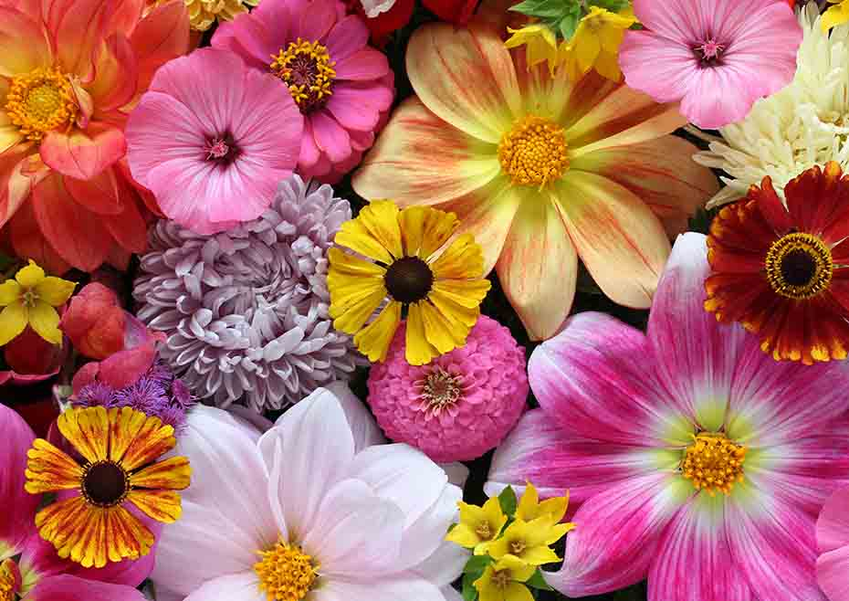
Key knowledge
- To know what the natural patterns and textures are in a flower
- To know and explain what shaping, carving and joining means.
- To know how to use our hands and fingers to shape petals
- To know how to use tools to carve out patterns in the petals and the middle of the flower
- To know how to join pieces of clay together.
Key skills

- Mould and shape petals out of clay using fingers and tools.
- Use different tools to carve patterns into the clay.
- Use different joining techniques to join the petals and the middle of the flower together.
- Mix the primary colours to make secondary colours.
- Paint the different parts of the flower carefully

Key vocabulary
Shaping (moulding) – making a shape using your fingers
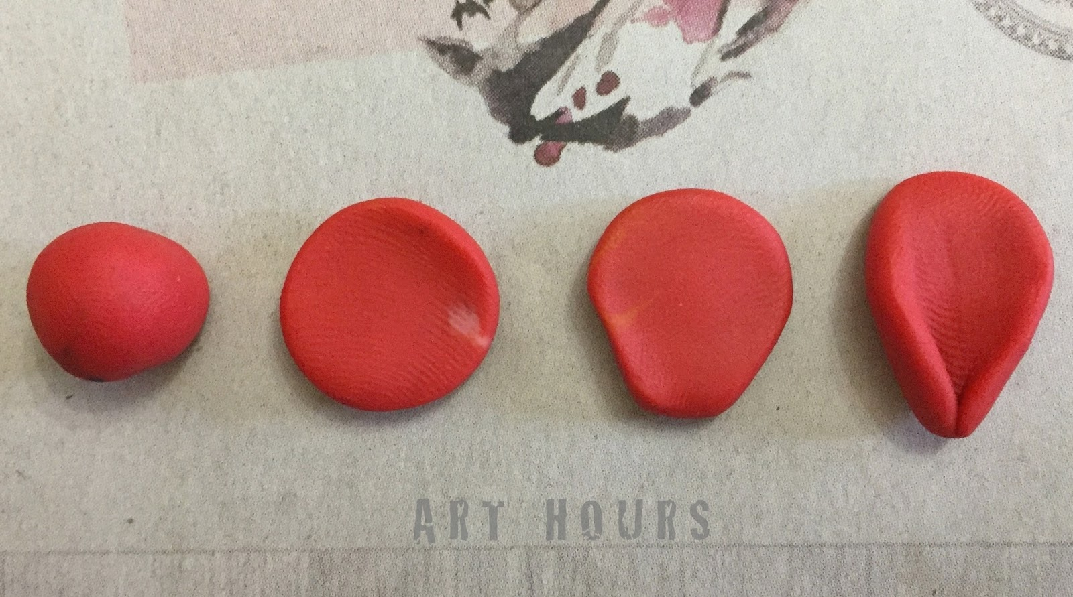
Carving – removing clay using tools
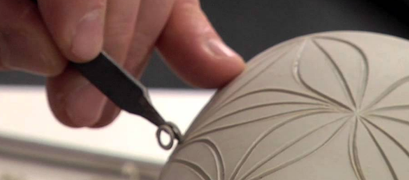
Joining – putting pieces of clay together
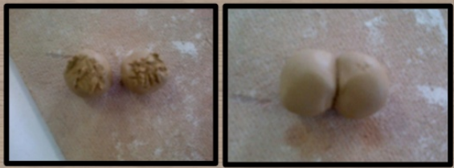

Key vocabulary
Pattern – a repeated design

Natural – something that is made naturally like flowers or trees.

Detail – The smaller parts of a picture or item e.g. the small stripes inside this flower
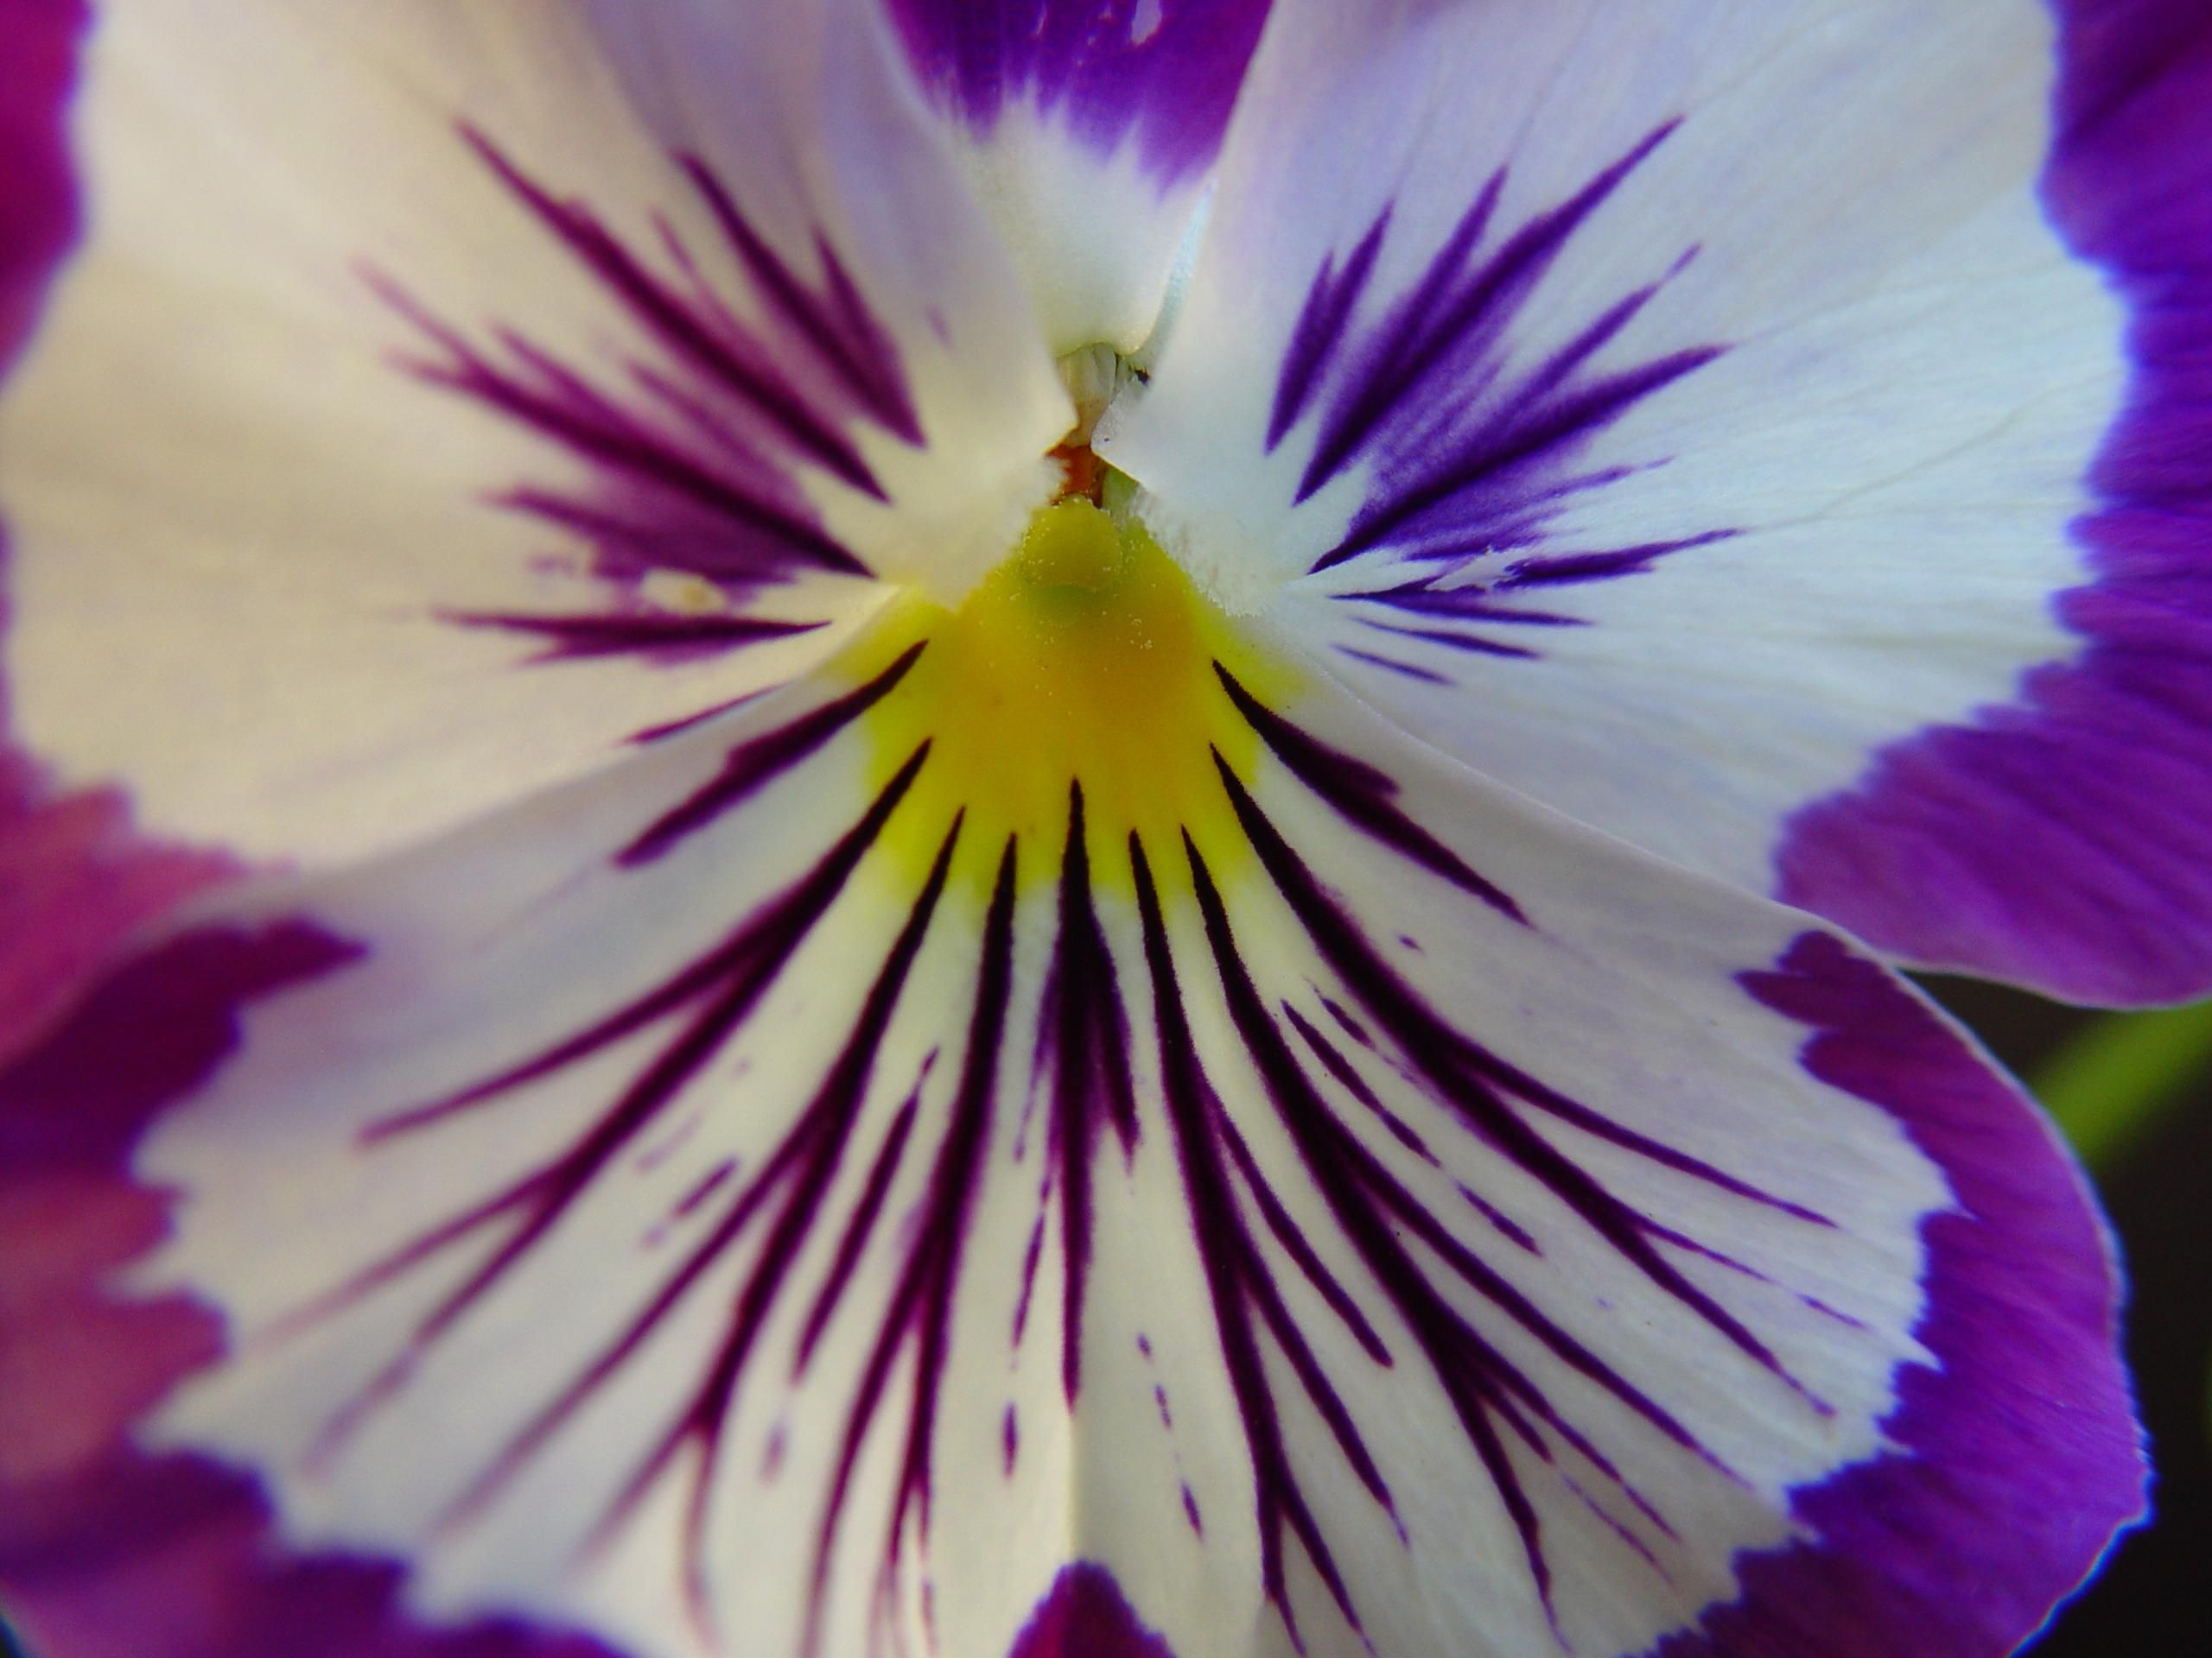

Texture – what things are made from.
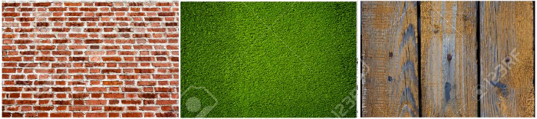

Year 2 – form

