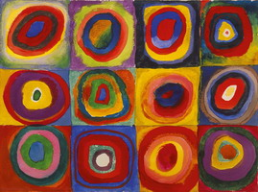
Key vocabulary
Primary colours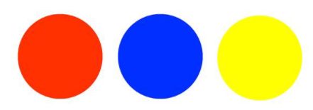
Secondary colours 
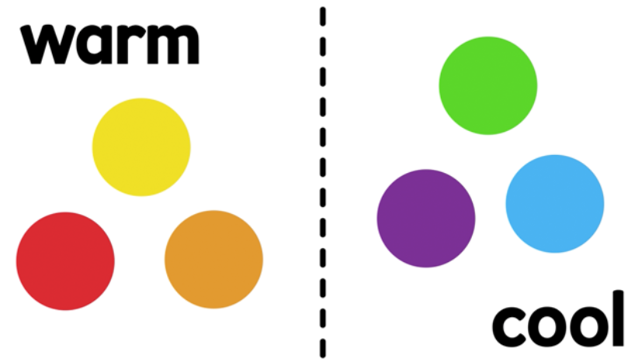

Key skills

- To be able to mix the primary colours to make secondary colours

- Explore prints
- Explain what a pattern is.
- Be able to change the shade
of a colour by adding black or white
- Be able to create a print
Key knowledge
- To know what the primary colours are
- To know how to mix the primary colours to make secondary colours
- To know what warm and cold colours are
- To know what adding black or white does to a colour
- To know how to use pattern to create a print
Key vocabulary
Pattern – a repeated design.
Printing – moving images onto different places using one object. 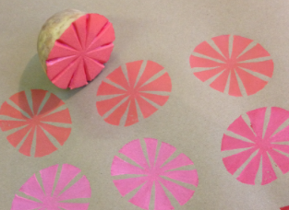
Repeating – the same thing over and over again.


Year 1 – painting/printing

