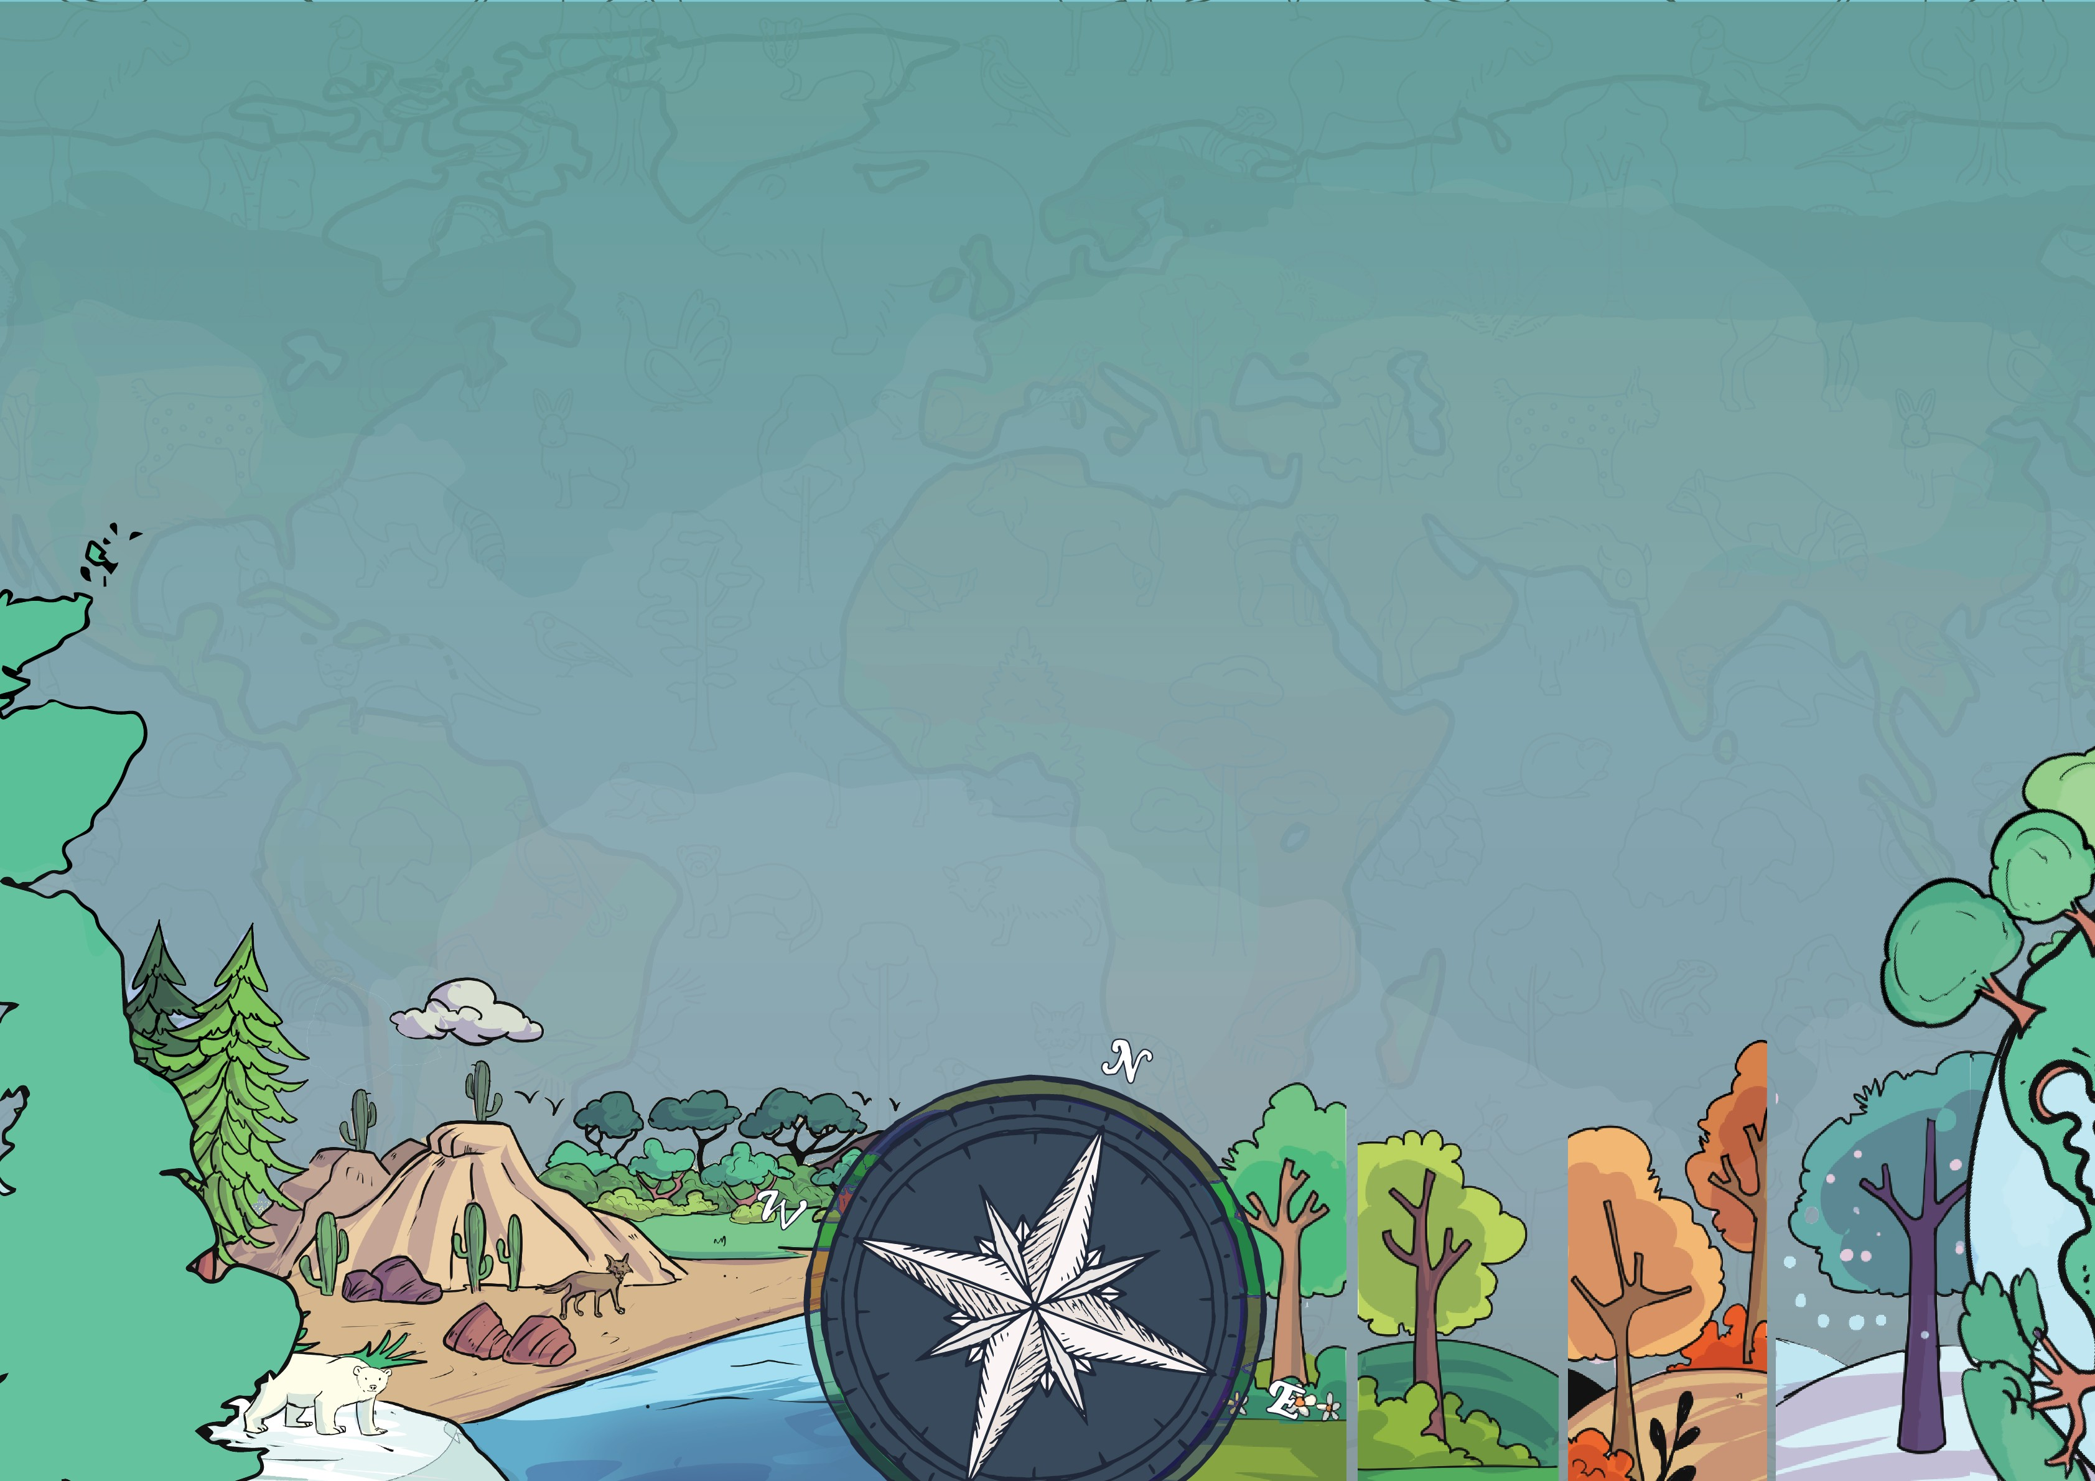
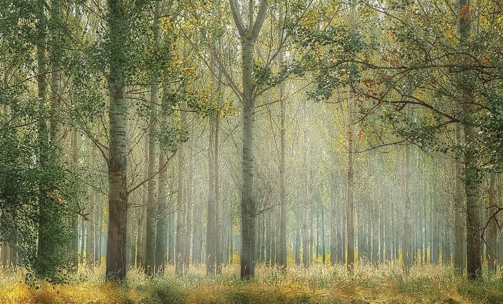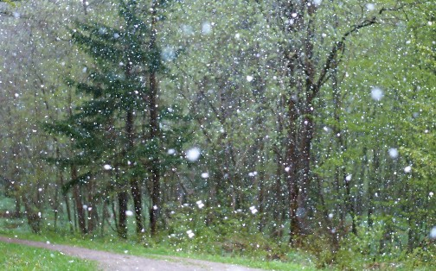
Year 5
Knowledge Organiser

Biomes and Ecosystems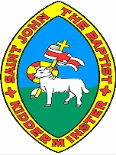
What is it like in a temperate forest biome?

It often rains (but not too much). This is called precipitation. The average yearly rainfall in the UK is 108cm. This means plants get the water they need to grow.

Most of the trees are deciduous, meaning they lose their leaves in the winter, but there are many evergreens here too.

Rotted leaves and other decaying matter provide rich, deep, fertile soil for trees to grow strong roots.

There are four distinct seasons: winter, spring, summer, and autumn. Each season is about the same length of time.

What is a biome?

Biomes are areas across the world which have a similar environment. This means they have similar climates, landscapes, animals and plants.
World Vegetation Belts
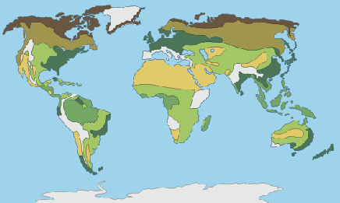
tropical rainforest grassland rainforest
coniferous forest deciduous forest deserts

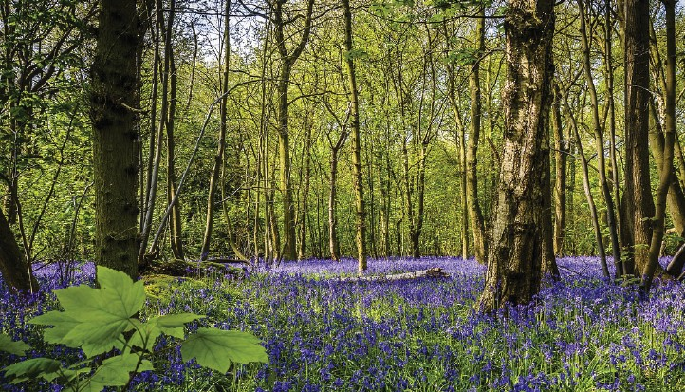
The UK has a temperate forest biome.
Temperate means 'not to extremes' or 'in moderation.’ In this case, temperate refers to the temperature in the UK.

What is a vegetation belt?

Like a biome, a vegetation belt is an area with the same type of plant life (or vegetation).
Whereas a biome refers to all living things, a vegetation belt is only the trees and plants that grow there.

The UK’s biome

Biomes of the world
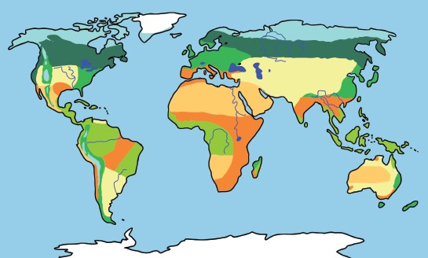
tropical rainforest desert taiga (boreal forest) savanna/tropical marine
grassland
temperate forest tundra grassland freshwater ice

What animals are found in the temperate biome in the UK?

Various animals live here, including badgers, foxes, deer, squirrels, rabbits, bats, adders, frogs, newts, and toads.

The UK is also home to many species of invertebrates, such as spiders, insects, moths and butterflies, and many birds and fish. Some animals, like birds, migrate to a warmer place for the winter. Some other species migrate to the UK for the winter as it is warmer than their homes further north. Some animals (such as hedgehogs) hibernate or rest during the winter.

What is a deciduous forest vegetation belt?

In the UK, we live in a deciduous forest vegetation belt. A deciduous forest vegetation belt is where most trees and plants are deciduous, although some are evergreen trees.
This means they lose their leaves or flora in autumn and winter, and fresh growth grows in spring and summer. They do this to save energy, like how some animals hibernate.


www.grammarsaurus.co.uk

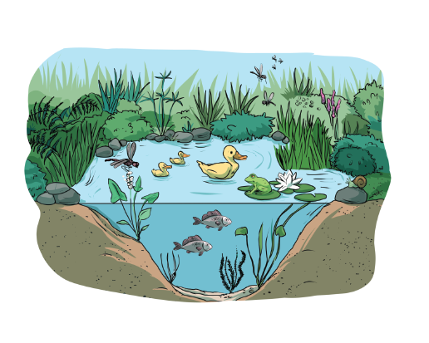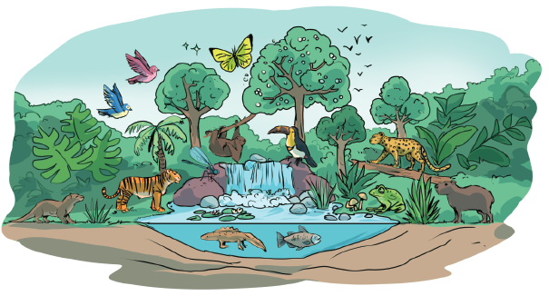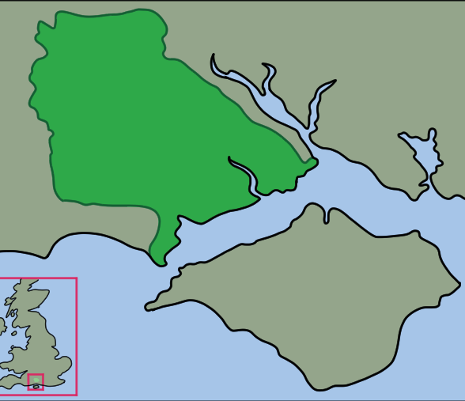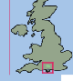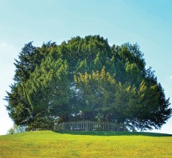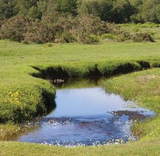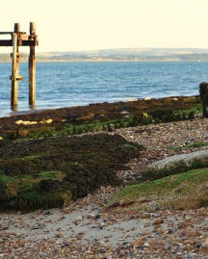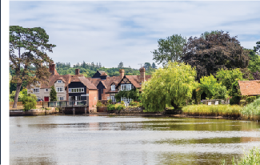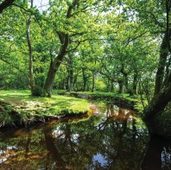
What ecosystems are found in the New Forest?

The New Forest has parkland, rivers, coastal areas, open land, forests and villages.
The different ecosystems that can be found in the New Forest include:
- heathland
- woodland
- trees

- gardens
- towns
- parks

- coastal
- beach
- river

The New Forest is an area in the South of England in the county of Hampshire. It is a large area of woodland, open grassland, heathland, rivers, villages and coastal areas.

What is the New Forest?

What ecosystems are found in the UK?
- farmland • wetlands
- urban areas – towns, cities • floodplains
- mountains • woodland and forests
- moorland • grassland
- heathland • coastline
- freshwater – rivers, ponds, lakes

An ecosystem is all living things in a given area interacting with each other and their non-living environments
What is an ecosystem?

Ecosystems can be very big (like the Amazon Rainforest)…
…or very small (like a pond).

Southampton
The New Forest National Park
Portsmouth

Isle of Wight
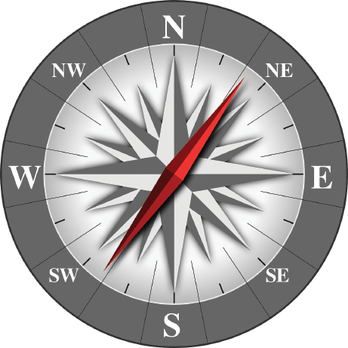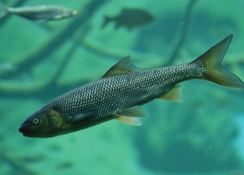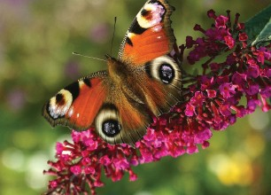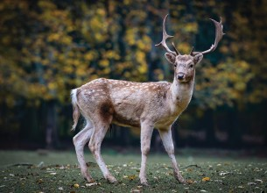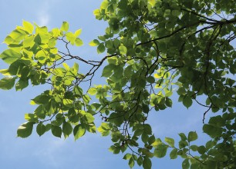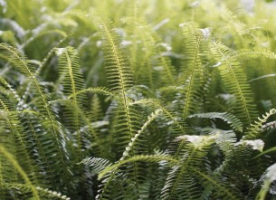
Other animals found in the New Forest include ponies, donkeys, horses, cows, pigs, deer, sheep, rabbits, foxes, hares, badgers, hedgehogs, squirrels, pine martins, mice, voles, otters, bats, birds, reptiles, amphibians, fish and invertebrates.

What animals are native to the ecosystem in the New Forest?

Using a compass

There are 8 points of a compass: North, North-East, East, South-East, South, South-West, West and North-West.

North
North-West
North-East
West
East
South-West
South-East
South

What trees and plants are native to the ecosystem in the New Forest?
There are many species of tree found in the New Forest. The most common are the beech, silver birch, elm, oak and ash. There is abundant plant life in the New Forest: ferns, moss, gorse, grasses and woodland flowers.
www.grammarsaurus.co.uk

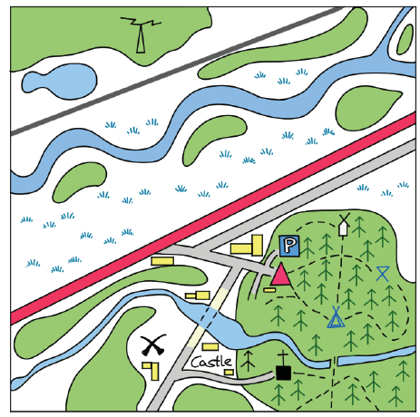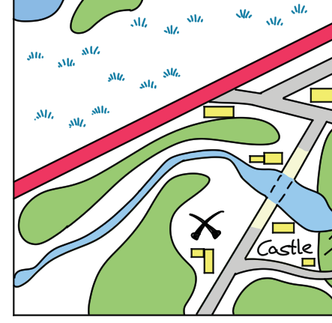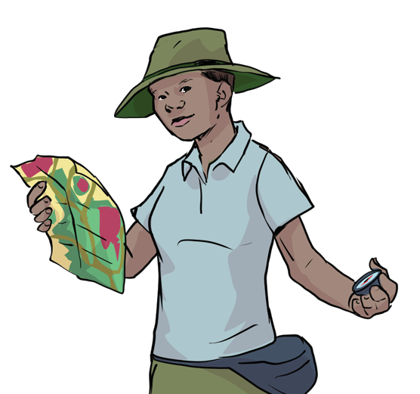
Sometimes, it is necessary to be even more accurate than four-figure grid references. To do this, imagine that each grid is divided into 100 squares. First, find the four-figure grid reference, but leave a space after the first two digits. Measure how many tenths across the grid square your symbol lies. Write this number after the first two digits. Then, estimate how many tenths up the grid square your symbol lies. Write this number after the last two digits. You now have a six-figure grid reference.

The grid reference for this red cross is 1431.
Each square has a grid reference, which you get by putting together the numbers of the northings (the horizontal lines going across the map) and the eastings (the vertical lines going up and down on the map). This is written as four digits.
Four-figure grid references

Six-figure grid references

Four-figure grid references

Each square has a grid reference, which you get by putting together the numbers of the northings (the horizontal lines going across the map) and the eastings (the vertical lines going up and down on the map). This is written as four digits.
35
34
32
33
31
The grid reference for this red cross
is 1431.
32
30
13
14
15
31
30
13 14 15
16
eastings
17 18

analyse – try to understand the information the data is showing

present – explain what you found out by adding graphs to make it easier to understand, as well as label maps, sketches and photographs

evaluate – think about how well you carried out your investigation and think about what you will improve next time
northings
lake

52
175,512
51
50
16
17
18
Conducting Fieldwork

Conducting Fieldwork - Presenting data

Data Collection Skills

- observing – looking at something carefully to find out about it
- measuring – using different tools to find out about something accurately
- recording – making careful notes and keeping accurate records about what you find out

Types of Data

We can collect data in different ways. This can be qualitative or quantitative.

Qualitative fieldwork is when we collect data that can give you in-depth information about specific things, e.g., detailed annotated drawings, photographs, audio recordings, interviews, sketches, and sample collections.
Quantitative fieldwork is when we collect data which involves numerical information, e.g. counting, timing and measuring.

www.grammarsaurus.co.uk

