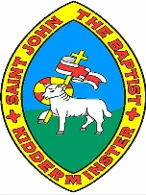
Year 1
Knowledge Organiser
The World and My School

Aerial plans

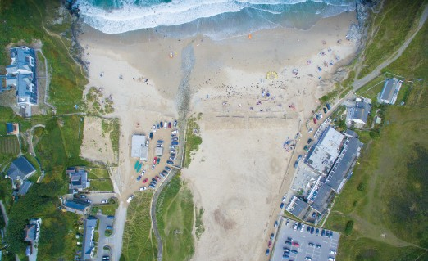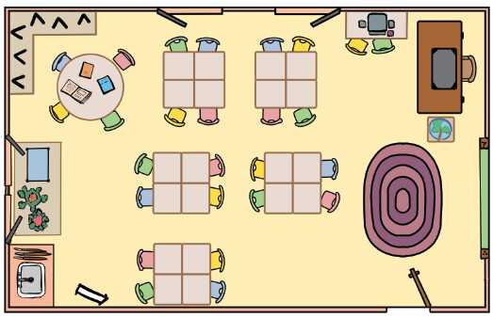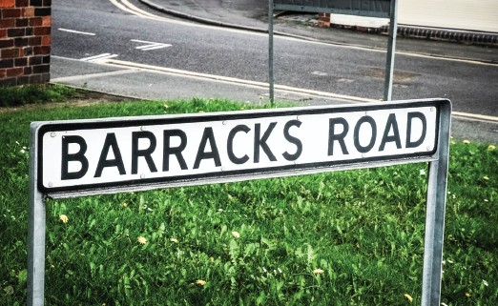
Human and physical features
Aerial photos
Street names

Human and physical features are things that you can see all around you.

Physical features like seas, mountains and rivers are natural. They would be here even if there were no people around.

Human features are things like houses, roads and bridges. People have built them.

An aerial view is a photo taken from above. You can look at the geographical features of a place using an aerial photo.
Buildings are usually placed along streets. Each street has a name.

Sometimes the street name can give you information about a feature on or near that street.

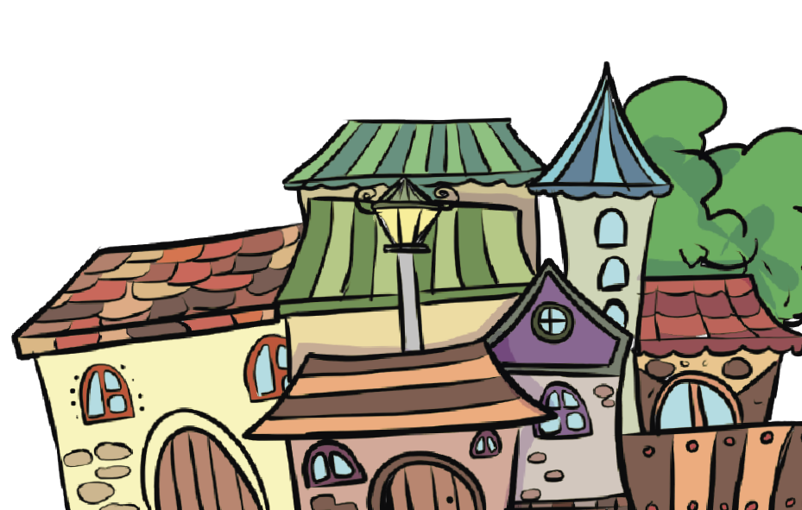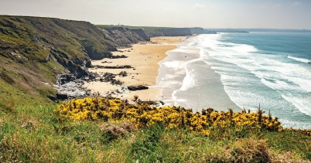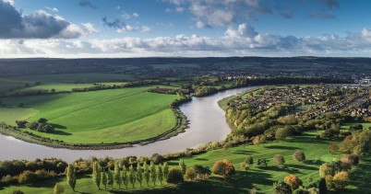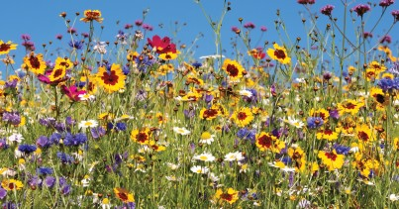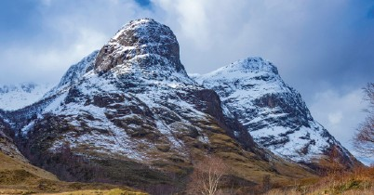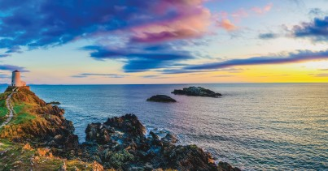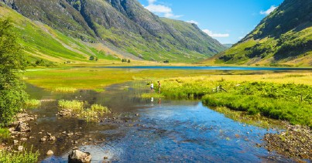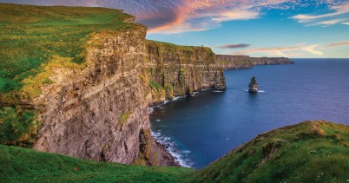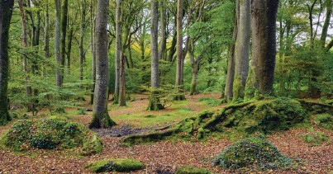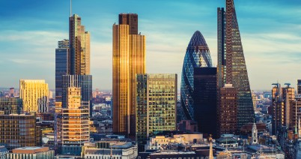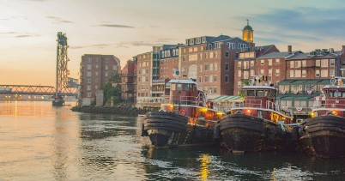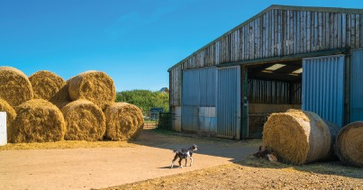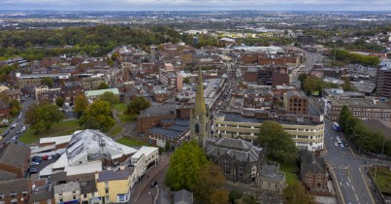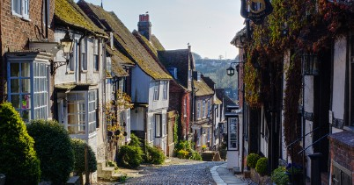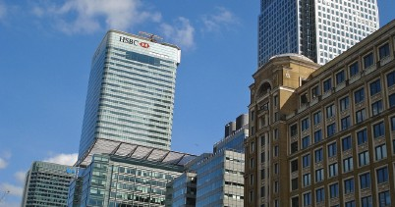
www.grammarsaurus.co.uk
Physical features
city
Human features
valley
soil
vegetation
farm
shop
port
ocean
mountain
river
forest
cliff
beach
factory
office
house
village
town

An aerial plan is a drawing that shows a small area or a building. It is useful because it tells us exactly where things are on the ground.

Climate
Weather
Types of settlements
The weather includes changes in temperature, the wind, the rain and much more. The weather can change daily.
The climate is the normal weather over time. The climate is like the weather but over a long time.

Settlements are places where people live and sometimes work. They can be small or large depending on how many people live and work there.

There are three types of settlements: villages, towns and cities.

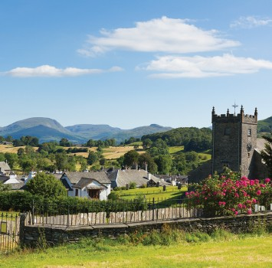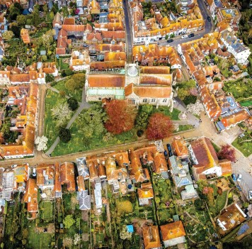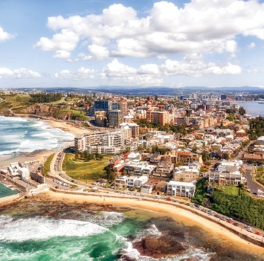

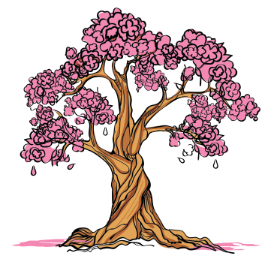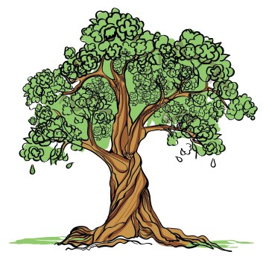

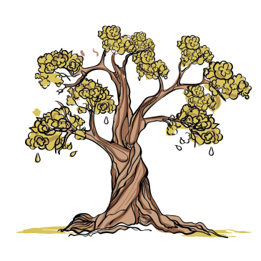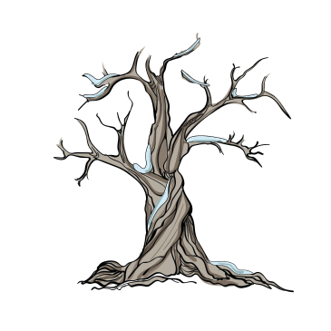

Newcastle City
Rye, Town
Hawkshead, Village
autumn
summer
winter
spring

Climate around the world
The United Kingdom
Where a place is on the planet will affect its weather and climate. The closer a country is to the equator, the hotter the climate! Some places have warm climates, neither too hot nor too cold. This is because they aren’t close to the equator or the North or South Pole.

The United Kingdom comprises four different countries: England, Scotland, Wales and Northern Ireland. It is sometimes referred to as Great Britain.

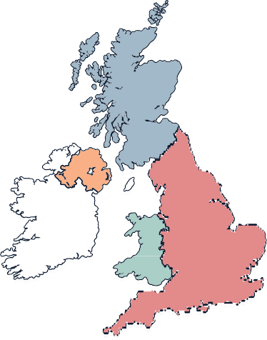
Climate key

Scotland
Scotland

Northern Ireland
Northern Ireland

Wales
Wales

England
England

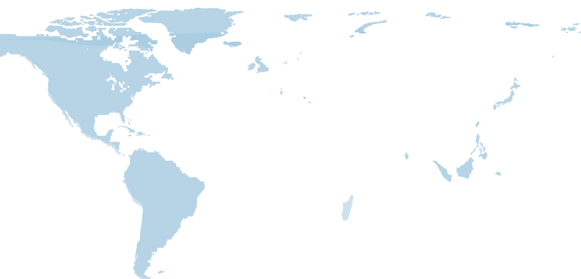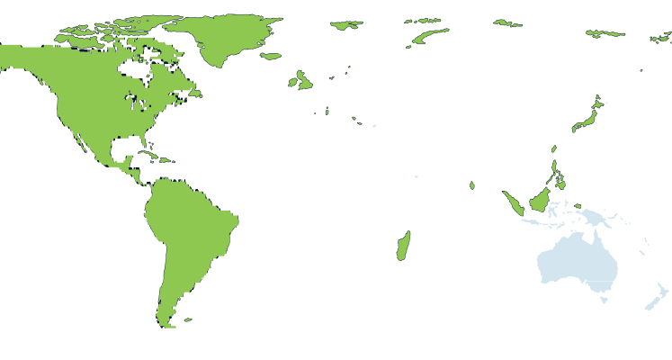
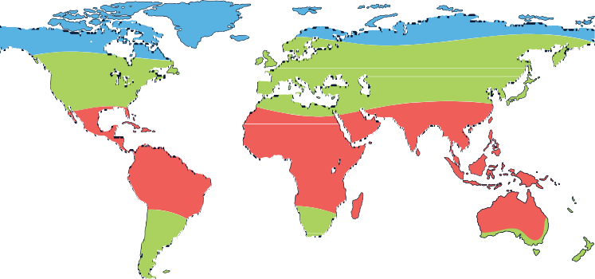

equator

North Pole
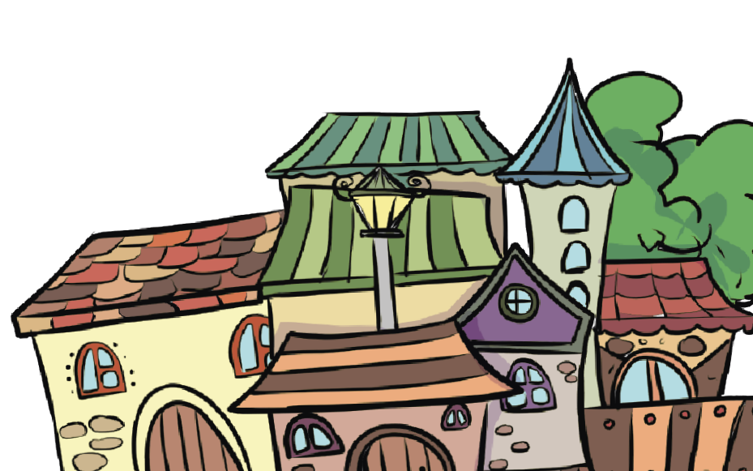
Climate key hot warm cold
hot

warm

cold

The United Kingdom
The United Kingdom


South Pole

www.grammarsaurus.co.uk



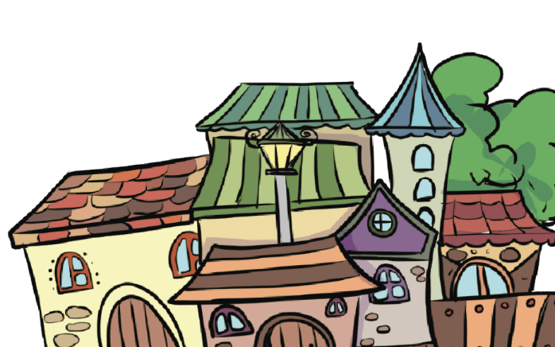

www.grammarsaurus.co.uk
The world has big areas of water called oceans
The world is divided into big pieces of land called continents
Continents and Oceans of the World
There are five oceans: the Pacific Ocean, the Atlantic Ocean, the Indian Ocean, the Southern Ocean, and the Arctic Ocean.
There are seven main continents: North America, South America, Europe, Asia, Africa, Oceania, and Antarctica. Each continent has its own countries, animals, and people.

