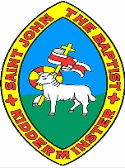
My Region and
the Western United States
Knowledge Organiser
Year 5

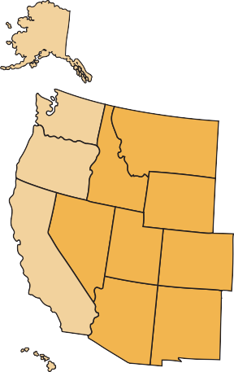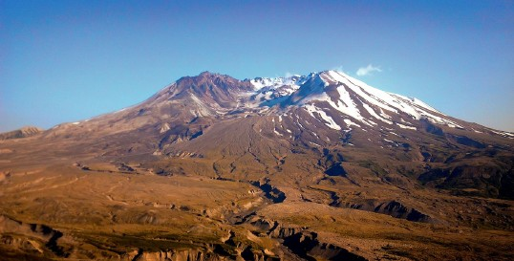
The Western region of the USA consists of 13 states: Alaska, Arizona, Colorado, California, Hawaii, Idaho, Montana, Nevada, New Mexico, Oregon, Utah, Washington and Wyoming.

The USA is one of the 23 countries which make up the continent of North America. The country is divided into four regions: the West, the Midwest, the Northeast and the South.

is the Cascade Range which is formed by thousands of small volcanoes. Rising above this volcanic platform are a few large volcanoes, like Mount Saint Helens, which dominates the landscape.

One of the large tectonic plates is the North American Plate. The edges of the North American Plate exhibit all three of the major plate boundary type of movements. California, Oregon and Washington have earthquakes and even volcanoes! Hawaii also has many active volcanoes, and extinct volcanoes can be found throughout the Western United States. An example of the volcanic zones in the Western United States

Alaska,
Juneau

Washington,
Olympia

Oregon,
Salem
Montana,
Helena
Idaho,
Boise

Wyoming,
Cheyenne
Nevada, Carson Cty
Utah, Salt Lake City
Colorado,
Denver
Arizona,
Phoenix
New Mexico, Santa Fe
Hawaii,
Honolulu
Volcanoes and earthquake zones of the Western United States
The Western United States

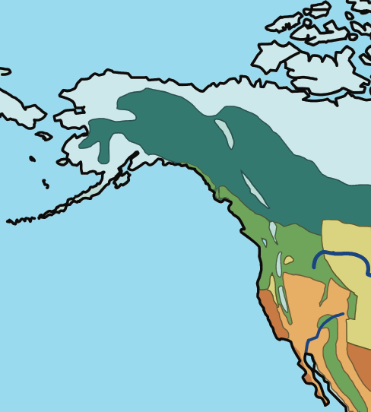
The biomes and climate zones of the Western United States
The vegetation belts of the Western United States
The Western United States extends across a wide range of vegetation belts, including the following: tundra, coniferous forest, desert and dry shrub, Mediterranean shrub and temperate grassland.

A biome is a large area on the Earth’s surface defined by the types of animals and plants living there. We can also consider these “life zones” (“bio” means life). The Western United States includes tropical rainforest, desert and tundra biomes, to name a few.

Climate change is an ongoing issue that affects each of these vegetation belts. We have seen the devastation of forest fires, particularly across desert areas of California, which have destroyed homes and habitats for humans and animals alike. In addition, the polar ice caps are reducing rapidly, and northern Alaska is directly impacted as a result as it lies within the Arctic Circle.

tropical rainforest temperate forest desert
tundra
taiga (boreal forest)
grassland
savannah (tropical grassland) freshwater
marine
ice

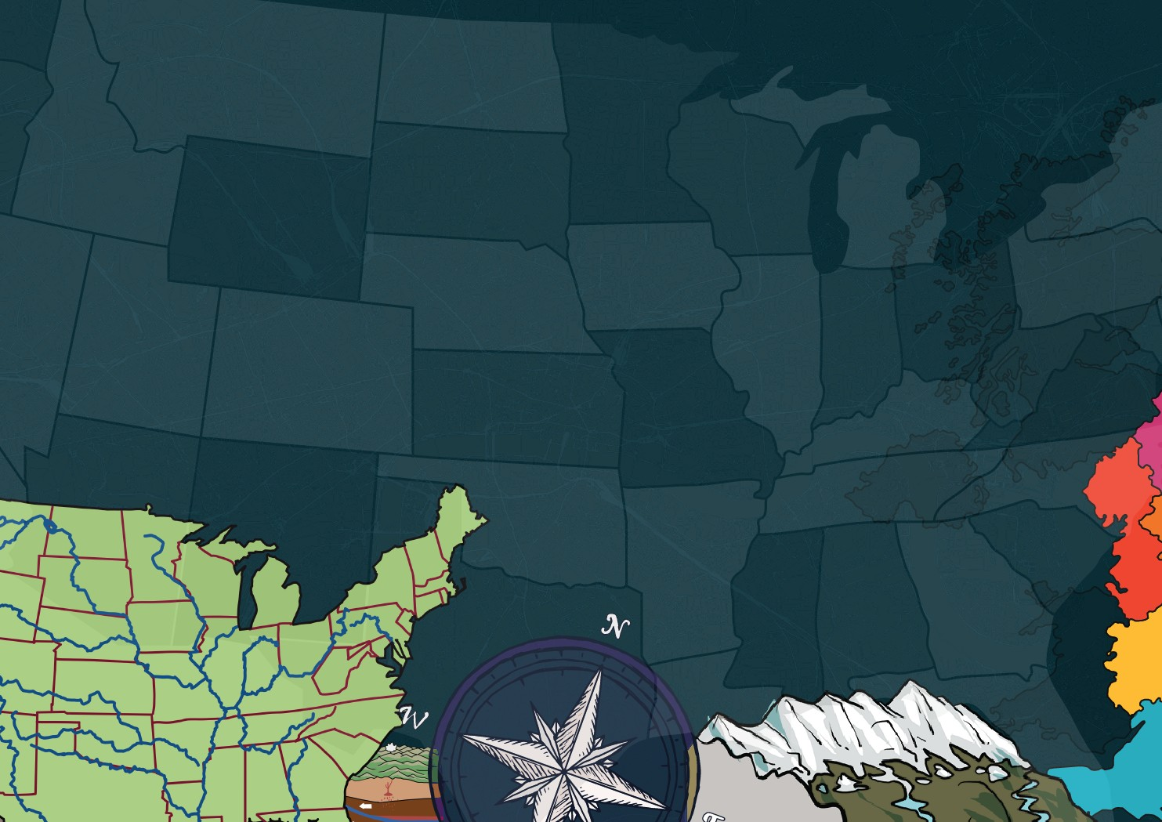


www.grammarsaurus.co.uk

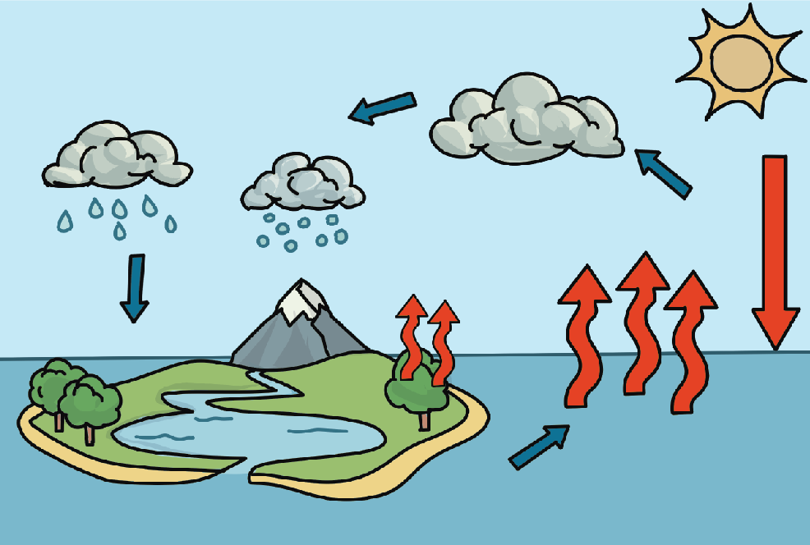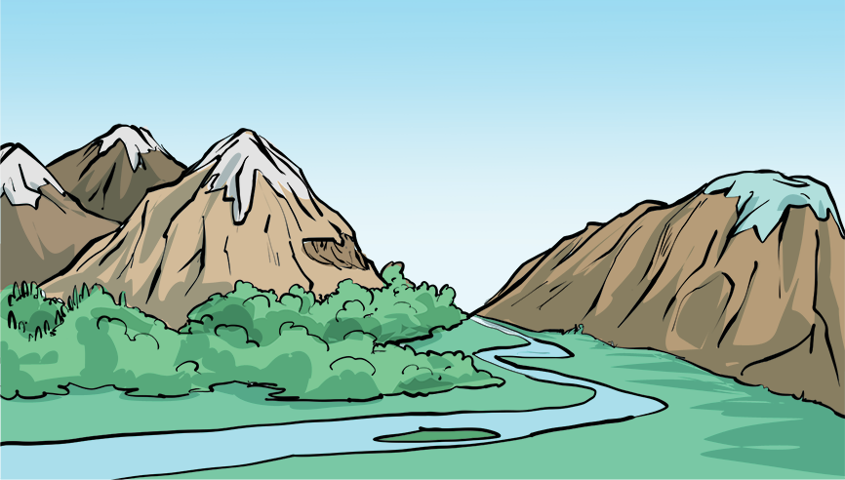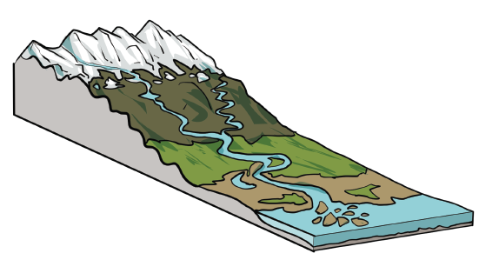
What are mountains?
The water cycle
The water cycle
condensation
precipitation
heat
evaporation
transpiration
run-off

accumulation

Key features

delta
mouth
channel
oxbow lake
meander
estuary
levee
river
source
confluence
tributary
Diagram of a river system

Mountains are areas of land much higher than the land surrounding them. They are higher and usually steeper than a hill. They are normally over 600 metres high. They are usually found in a group called a mountain range. Lines of ranges form mountain belts
The water cycle has four main parts: evaporation, condensation, precipitation and accumulation.

outcrop
a rock formation visible from the surface

valley
the area of low land between mountains

summit
the top of a mountain

slope
an area of ground increasing in height

snow line
above here snow and
ice cover the mountain
all year

plateau
an area of flat,
high ground

face
the “side” of a mountain

foot
the bottom of the mountain

ridge
a long, narrow, high section of land

treeline
the highest point at which forests are found

What are rivers?
- Evaporation happens when the Sun causes the water in the rivers, lakes and oceans to heat up and turn into a water vapour gas, which then goes into the air. Water from plants and trees also enters the atmosphere. This is called transpiration.

- As the water vapour rises during the evaporation stage, it cools down and turns back into liquid, causing droplets to form, becoming clouds. This is called condensation.

- When a cloud becomes too full and heavy, the water falls to the ground as precipitation. Precipitation can take the form of rain, sleet, hail or snow.

- When water falls back to Earth as precipitation, the Earth absorbs some of the water that falls to the ground. When the ground cannot absorb the water, it flows over the land, known as ‘run-off’. The water that runs over the ground accumulates in rivers, lakes and oceans. This is called accumulation.

A river is a naturally moving body of water. It flows from its source on high ground, across the land, and then into another body of water. This could be a lake, the sea, an ocean or even another river.

www.grammarsaurus.co.uk

