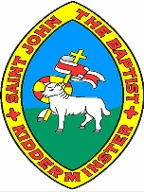
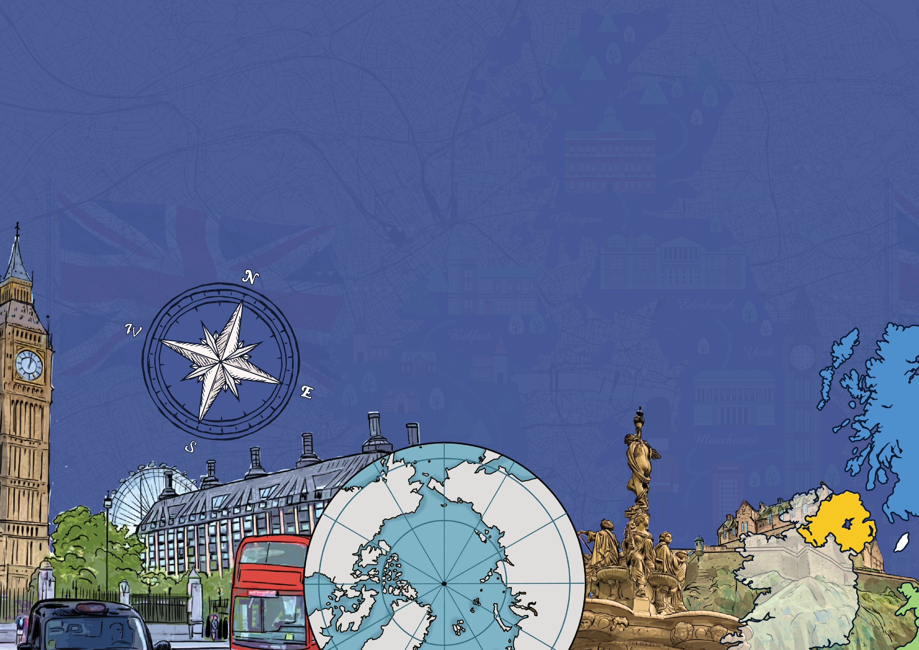
The United Kingdom and my region
Year 3
Knowledge Organiser
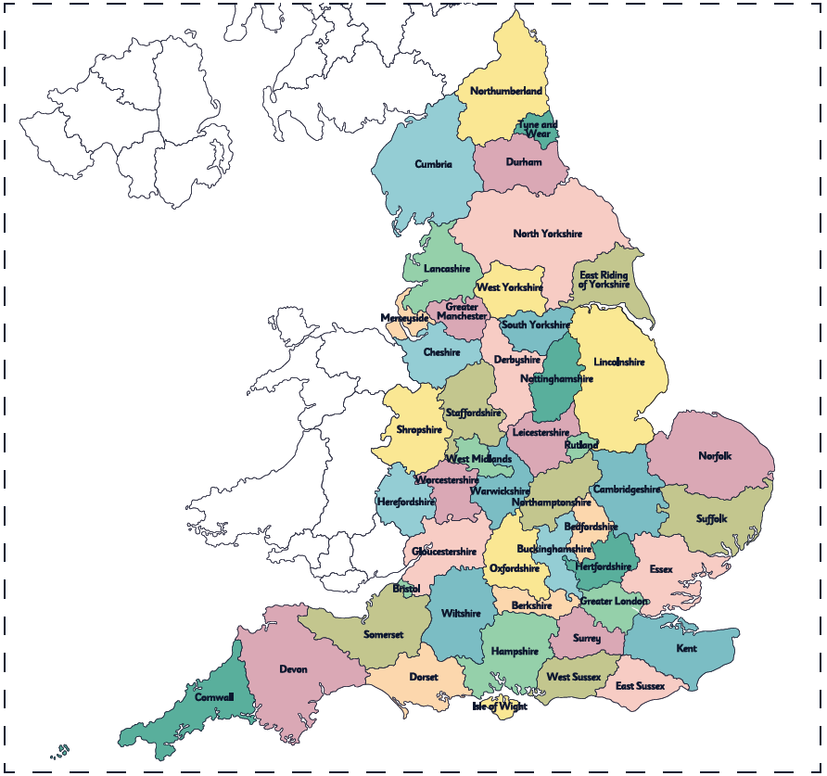
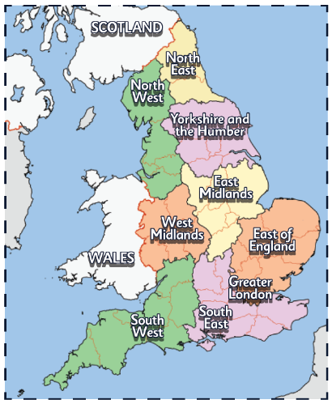
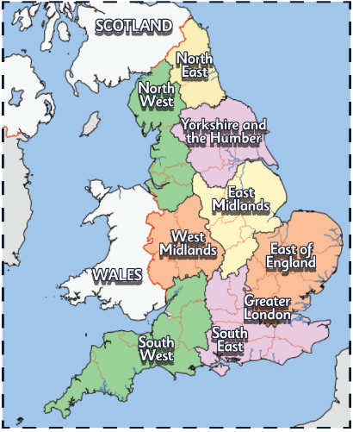
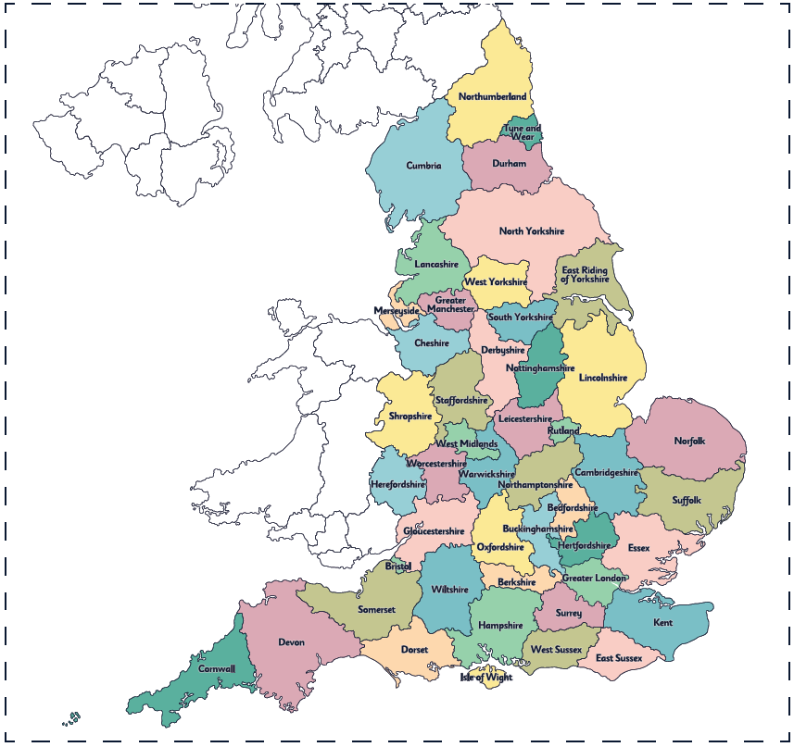
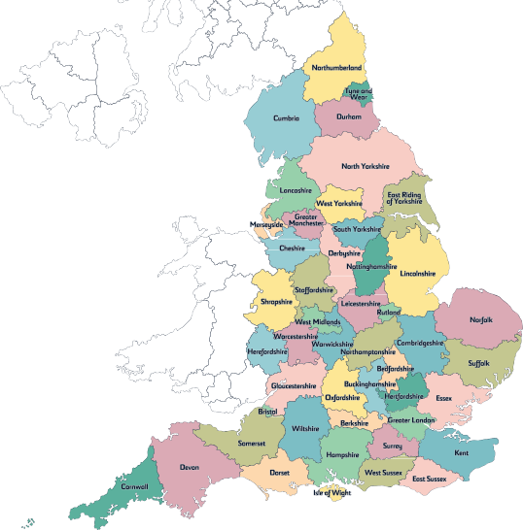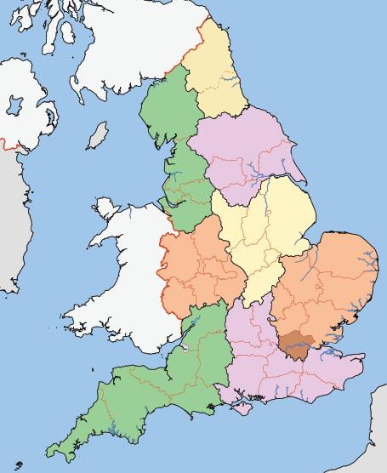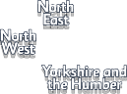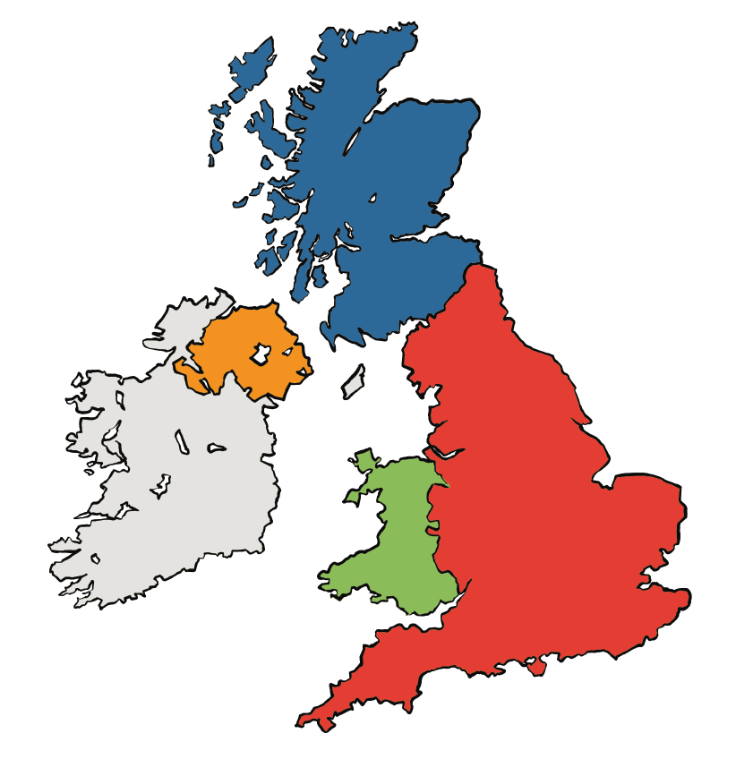
Counties
Counties are areas of land made up of countryside and
different settlements. Here are some interesting facts
about counties.
Regions
England is split up into smaller sections called regions.
Each of these regions contains counties, cities, towns and villages.
The United Kingdom
The United Kingdom of Great Britain and Northern Ireland is an
island country in Europe.

It is made up of four smaller countries: England, Northern Ireland, Scotland and Wales.
SCOTLAND
Edinburgh
Each country has a capital city,
as shown on this map.
NORTHERN
IRELAND Belfast
ENGLAND
WALES
Cardiff
London
Settlements

There are three main kinds of settlement: villages, towns and cities. They are classified depending on how big or small the settlements are and the kinds
of housing and facilities they have.



places of worship
supermarket
shops, restaurants, pubs and hotels
swimming pool
busy roads
secondary school
lots of houses
What is a town?
lots of restaurants, cafes and bars
office blocks lots of different
houses, including blocks of flats
warehouses and factories

a university
a cathedral

lots of different places of worship
museums and galleries

parks

shopping centres
What is a city?
a primary school
a post office and shop
a church
quiet roads
a pub
not many houses
What is a village?

www.grammarsaurus.co.uk

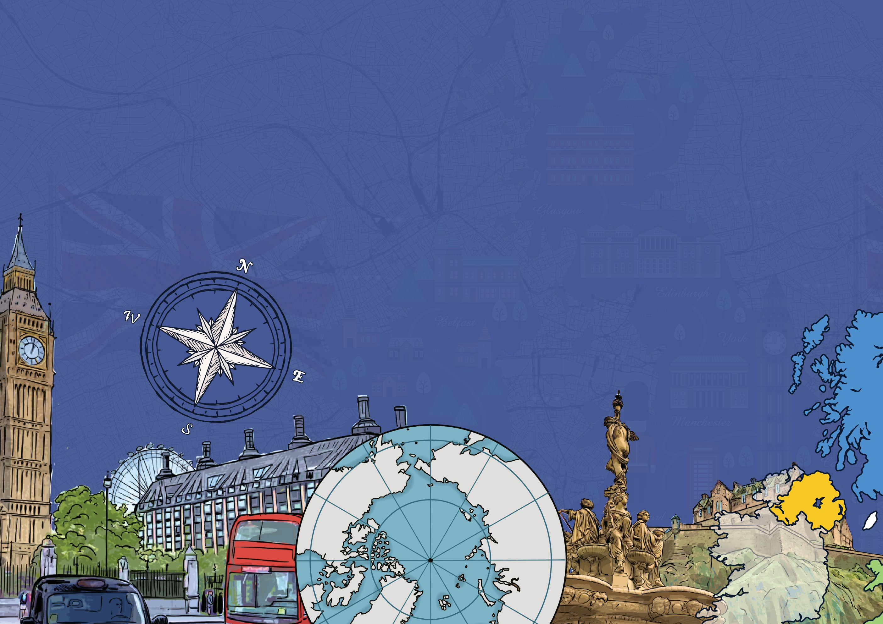
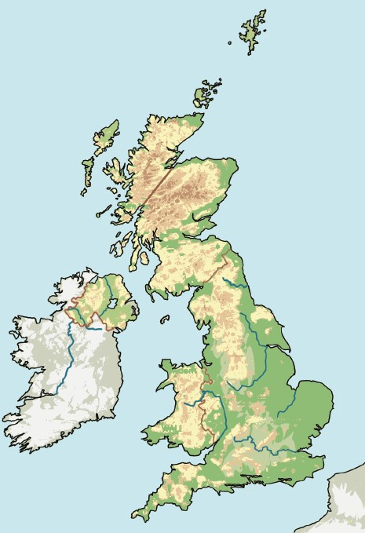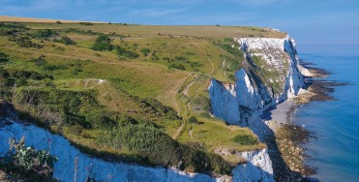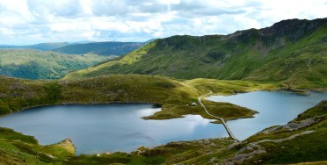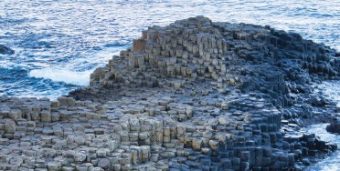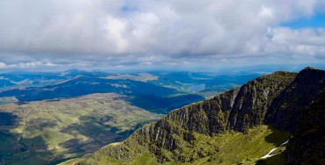
Compasses
Physical features of the UK

The landscape of the UK is very varied. Physical features would be here even if there were no people around
(e.g. seas, mountains, rivers).

Shetland Islands

Orkney
Ben Nevis 1345m
North Sea
North Atlantic Ocean
SCOTLAND
NORTHERN IRELAND
Scafell Pike 978m
Snaefell
Slieve Donard 850m
Irish Sea
IRELAND
Snowdon (Yr Wyddfa) 1085m
WALES
ENGLAND
English Channel
The cliffs on the coastline are famous here. They are called the White Cliffs of Dover.
Snowdonia National Park, the Cambrian Mountains and the Brecon Beacons are the mountain ranges in Wales.
The Northern Highlands and the Grampian Mountains are the mountain ranges in Scotland.

The Giant’s Causeway is an amazing rock formation on the coastline.
Human features of the UK

A human landmark is a human-made feature of a landscape or town that is recognisable from a distance.
Glenfinnan Viaduct, Inverness-shire,
Scotland
Wales Millennium Centre, Cardiff,
Wales
Titanic Belfast,
Belfast, Northern Ireland
Stonehenge,
Wiltshire, England

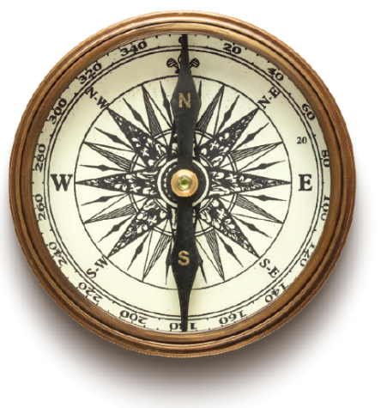
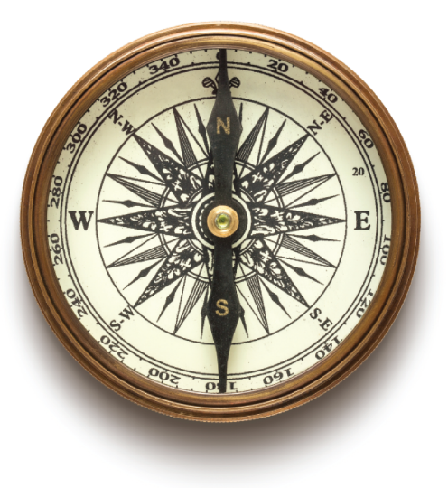
A compass is a magnetic instrument used for finding directions. The four directions on a compass are called cardinal directions. They are north, east, south and west. The needle within the compass will
always point towards the north.

Four-figure grid references

Four-figure grid references are four numbers used to pinpoint a particular location on a map. Numbered lines called eastings and northings are used to pinpoint a square section on a map.

grid reference: 3243

How to use them:
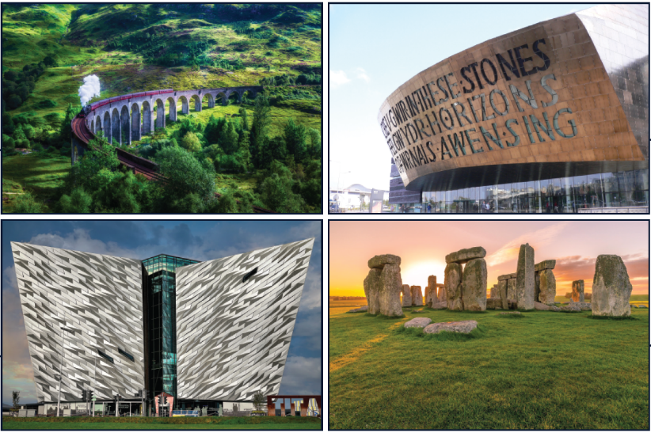
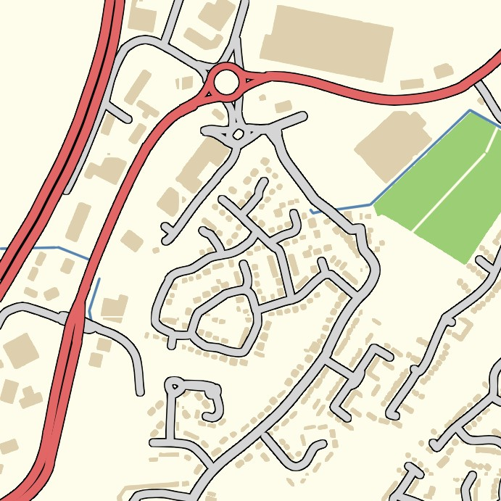

34
33
32
31
42
43
3. When you have found the correct corner, look at the square to the top right of
the corner.
3243
2. Then look at the northings
until you find the 2nd number.

44
1. Look at the eastings and
find the 1st number.
45
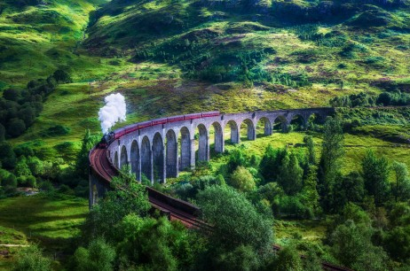 | 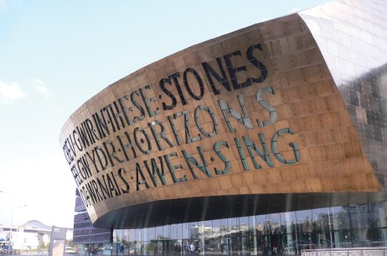
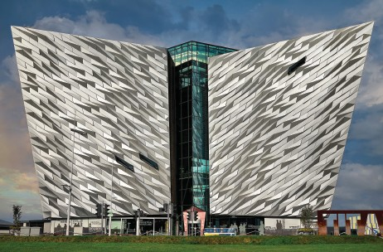 | 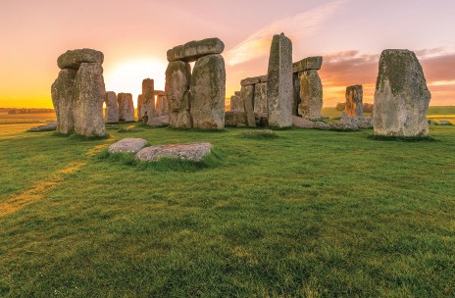

www.grammarsaurus.co.uk

