
Economic Activity of the UK
Knowledge Organiser
Year 6

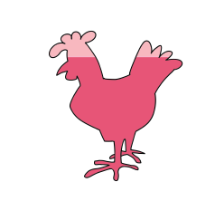

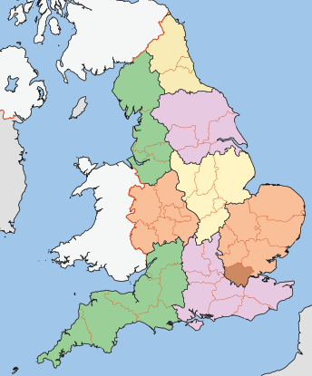


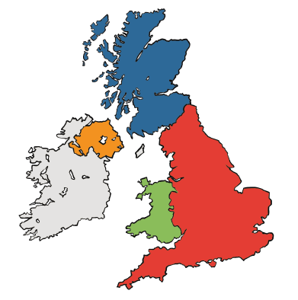

Agriculture
Sectors of the UK economy

Geography of the UK

The UK comprises four countries: England, Northern Ireland, Scotland and Wales. The capital cities of these countries are London, Belfast, Edinburgh and Cardiff. England is made up of nine regions shown in the map below:

In the UK, economic activity can be split into three different sectors: primary, secondary and tertiary:

Primary
sector

extracts and uses
natural resources of the Earth

Secondary sector

manufactures goods using the raw materials provided by the primary sector
In the UK, agriculture can be carried out 'intensively' or 'extensively.' Intensive farming involves small areas of land used for large crop and animal production. Usually, animals are kept in smaller spaces for this to be possible.

Intensive farming statistics

85%
85 million
25%

Tertiary sector

provides services to customers and their sectors of industries
Over 85% of the UK’s farmed land animals live in factory farms.
Demand for energy in the UK, 1995-2021
More than 80 million animals are living in intensive farms at any given time.

The number of mega-farms in the UK rose by more than 25% in the six years leading up to 2017 and continues to climb.


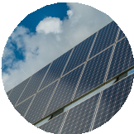
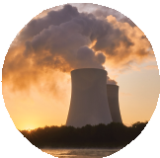


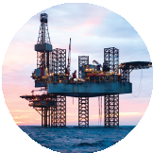
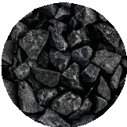
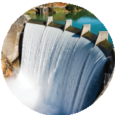
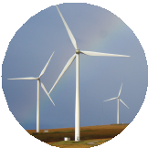
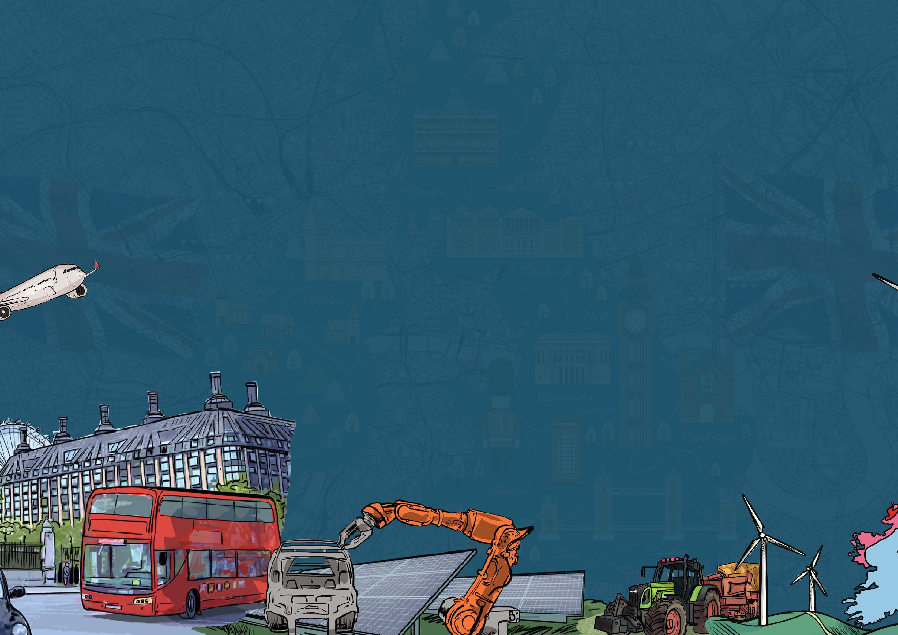
coal
nuclear
petroleum bioenergy and waste

natual gas wind, solar and hydro
Energy can be generated and captured from multiple different sources. These sources can be sorted into two categories: renewable and non-renewable. Renewable energy sources are naturally occurring and replenished in the environment. These could be used indefinitely without running out. Non-renewable energy sources are found on Earth in a finite supply, meaning a specific amount that will eventually run out.
Renewable and non-renewable energy sources
300
250
200

150
solar – renewable
wind – renewable
hydro (water) – renewable
nuclear – non-renewable
100

50

0
wave – renewable
coal – non-renewable
gas – non-renewable
oil – non-renewable
1995
2000
2005
2010
2015
2020
www.grammarsaurus.co.uk
Energy Generation
millions tonnes oil equivalent

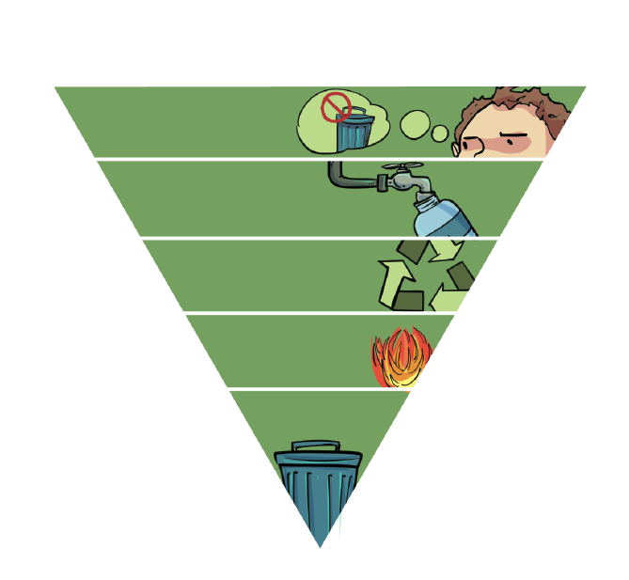


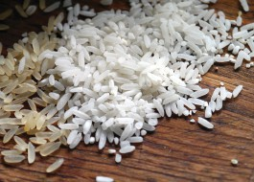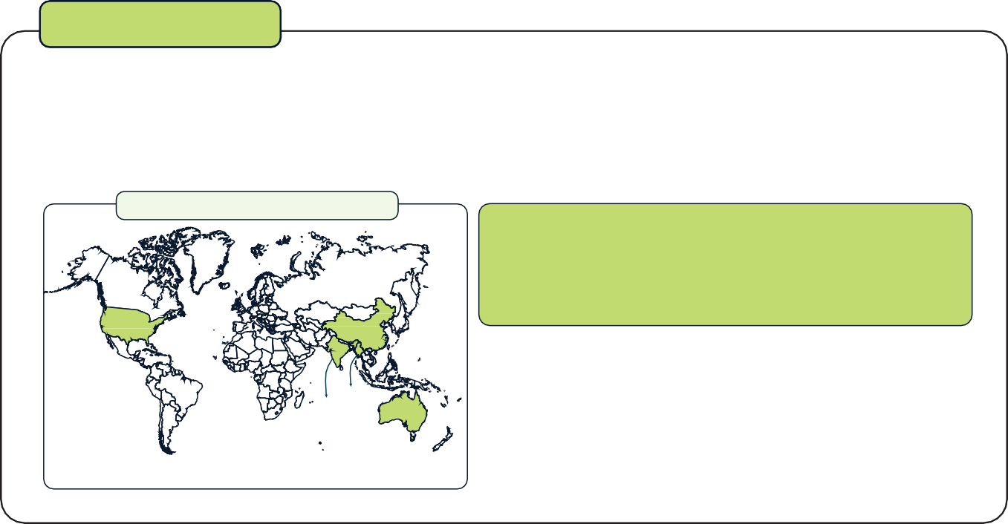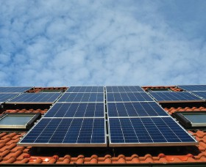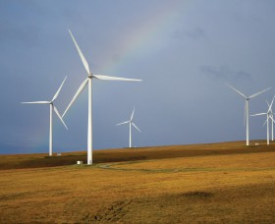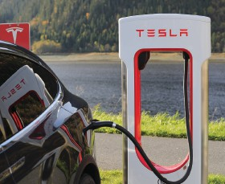
Waste management
Rare earth elements
Water use

Automation is the technology of completing a task using machinery with as little human assistance as possible. AI (artificial intelligence) is a form of automation which uses computers that are programmed with the ability to 'think' and learn.

Machines are less likely to make manual errors than humans. They also work faster than humans and don’t need breaks, making more products.
Machines can complete repetitive, tedious tasks, making human workers more happy. Once the machines have been purchased, they are cheaper to run than paying humans long-term. Computers can also be used for security and to recruit new staff by automatically choosing the best job applications.

The UK has developed a waste management hierarchy for dealing with waste produced in the country. Waste prevention is the key element of the hierarchy; refusing single-use plastics and using reusable products is the first step to reducing our environmental impact. Limiting our reliance on landfills is very important.
Waste hierarchy negatives of landfill
waste prevention

reuse
Lance
recycle/compost

energy recovery

disposal

Jamie

Water is one of the most important resources on Earth; we all need it to survive. Unfortunately, water is a finite resource, so there is only a certain amount that remains on Earth which is going through the water cycle. ‘Virtual water’ is water used to produce different products; when the UK uses these products, they ‘use’ the water used in their production.
Products with a high 'virtual' water footprint
coffee
cotton
rice
beef
avocados
almonds

'Rare earth elements' are seventeen elements used in many high-tech devices, e.g. smartphones and game consoles. A few countries, including China and the USA, produce most of these REEs. Creating mines to extract REEs is difficult as they are found thinly and evenly across the Earth's surface rather than in large amounts.
Top five producers of rare earths in 2019
We learnt in our energy generation lesson that moving to renewable energy sources is very important for the future of our planet.
Rare earth elements are needed to develop green energy technology like in these images.
Rare earth element shortages could affect the development of this ‘green’ tech.
US
26,000MT
China
132,000MT
Myanmar
all other producers combined
6,000MT
India 22,000MT 3,000MT
Australia
21,000MT
210,000
Global, metric tonnes
solar panels
wind turbines
electric cars

Automation

Landfill sites are overflowing, and eventually, we will run out of landfill space.

The hazardous waste is often improperly disposed of and ends up in a landfill. Hazardous waste can contaminate the soil and endanger animals, plants and humans.

www.grammarsaurus.co.uk

