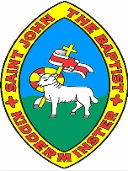

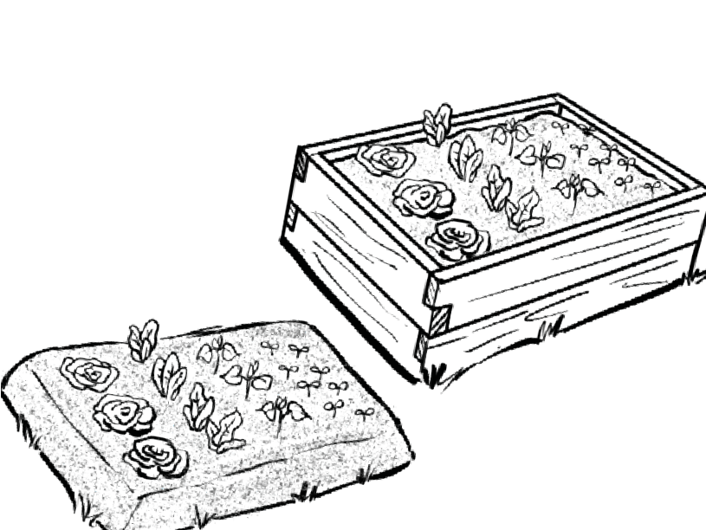

Our School Grounds
Year 1
Knowledge Organiser

Observational sketches can be used to record features. An architect might draw observational sketches when they are redesigning a location. A geographer might draw observational sketches when they are carrying out fieldwork.
Winter Street
Red Road
Main Street
Green Road
Maps
Observational sketches

Most maps are smaller drawings of a real place. They don’t always have space to include everything. To help us find important places on a map, we use symbols. This can help to make maps clearer and easier to read. It has symbols to represent different places.

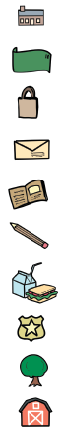

house

bank

shop

post office

library

school

restaurant

police station

park

farm
key:
key:

house

bank

shop

post office

library

school

restaurant

police station

park

farm
A key is used on maps to help you understand the
symbols.
Farm Lane
Leaf Street
Gold Street
Observational sketch of a raised flower bed | Observational sketch of a vegetable garden
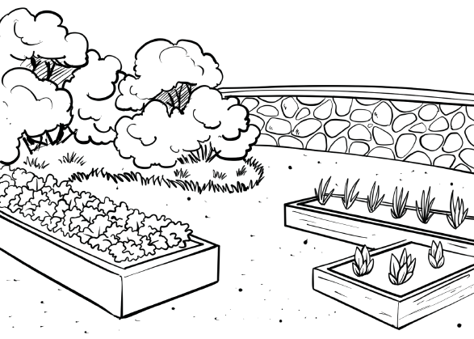

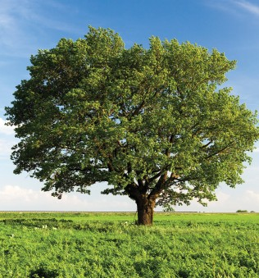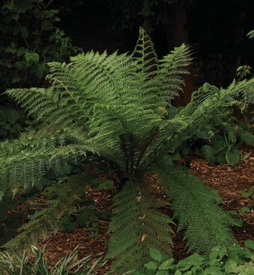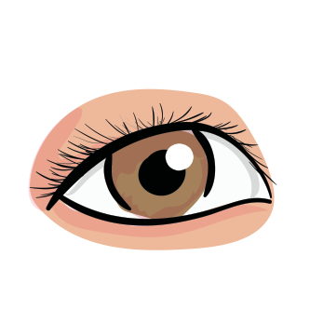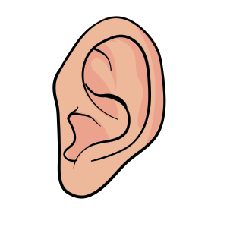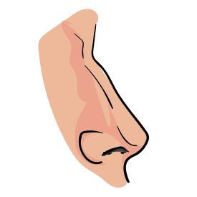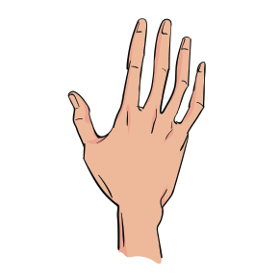
Our Senses
Plant life

Plants are living things that grow, usually on the Earth. Plants differ from animals because they cannot move from one place to another.
tree
flower
moss
fern

sight
hearing
smell
touch
www.grammarsaurus.co.uk

Fieldwork
Sketch maps

A sketch map is a drawing that shows the important things in a place, like a park or a classroom. It helps us remember where things are located and how to find them. We use simple shapes and lines to show different things when we draw a sketch map. For example, we can draw a square to represent a building, a circle for a tree, or a line for a path.

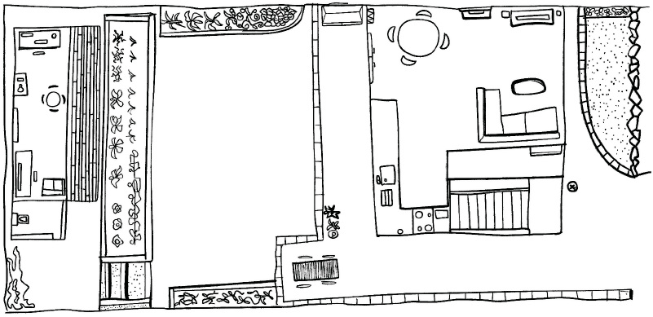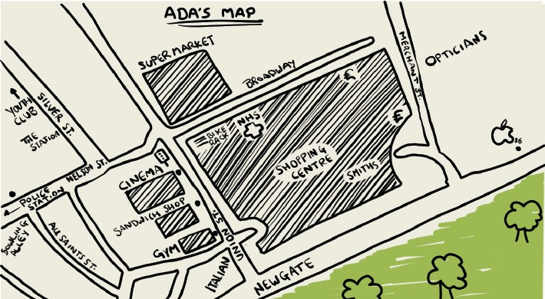

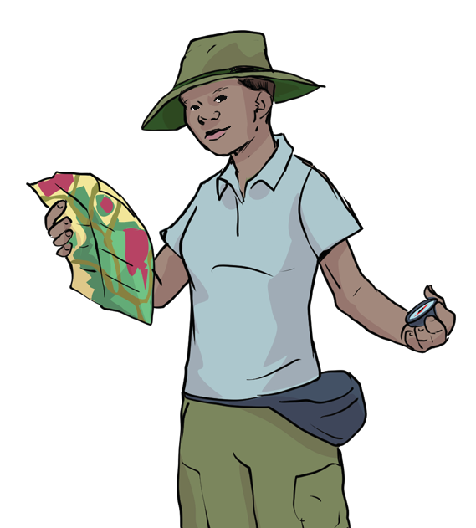Fieldwork is when you go outside and discover things about a place. Fieldwork includes investigating both human and physical features.

When conducting fieldwork, we must ask the following questions before we carry it out:

- What is the fieldwork you will carry out?
- Where and how will you carry it out?
- Why will you be doing it?

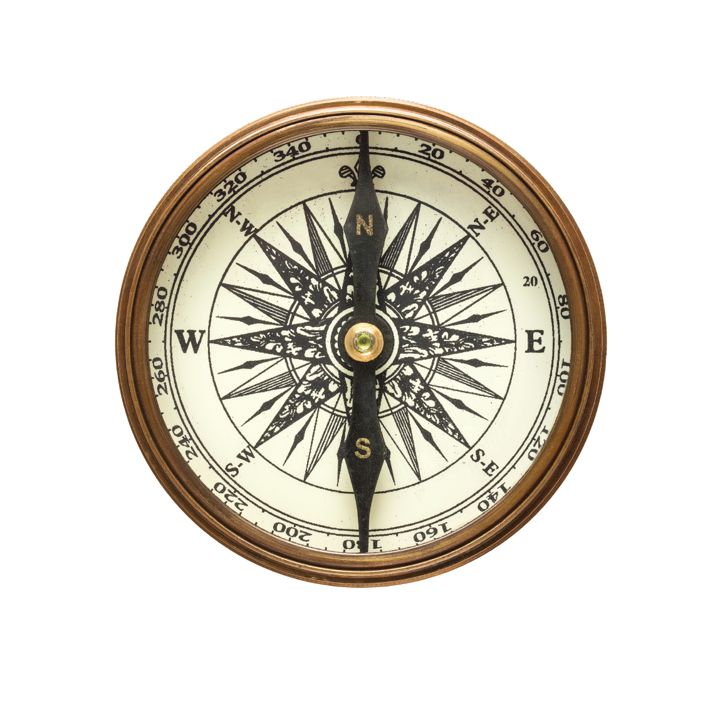

Directional language
Compass

forward
right
A compass is a tool used to help find directions. It has a needle that spins, and the needle always points north. The four directions on a compass are called cardinal points.

N – north E – east
S – south W – west

You can use this to help you remember!
Never Eat Silly Worms



downward
left

www.grammarsaurus.co.uk

