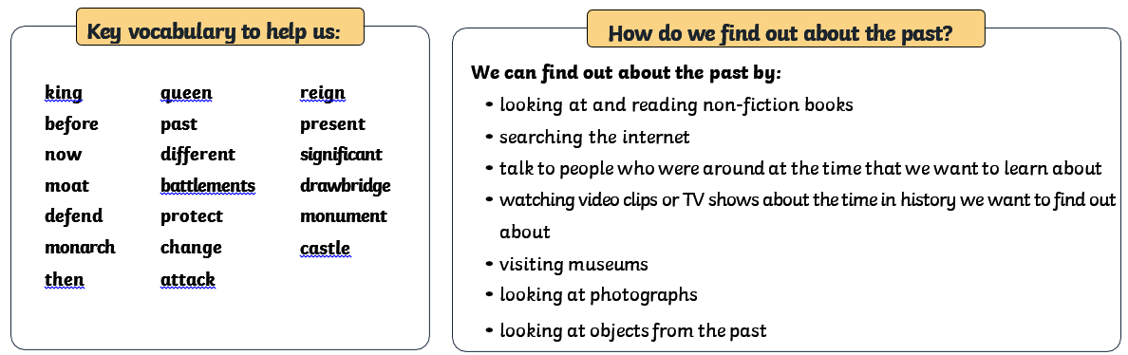


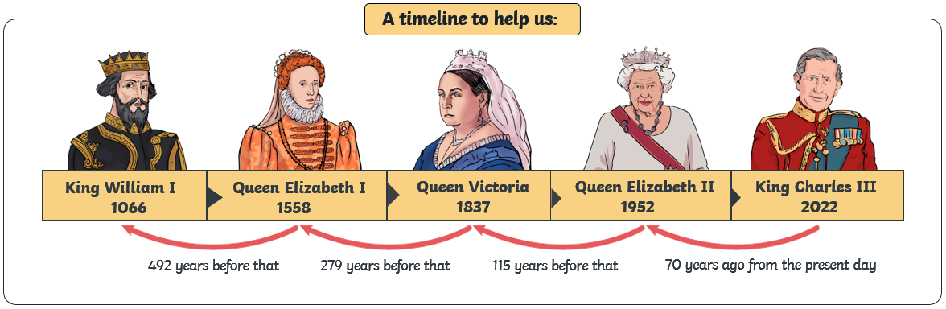
Rule Britannia Knowledge Organiser
Where did kings and queens live through time?
