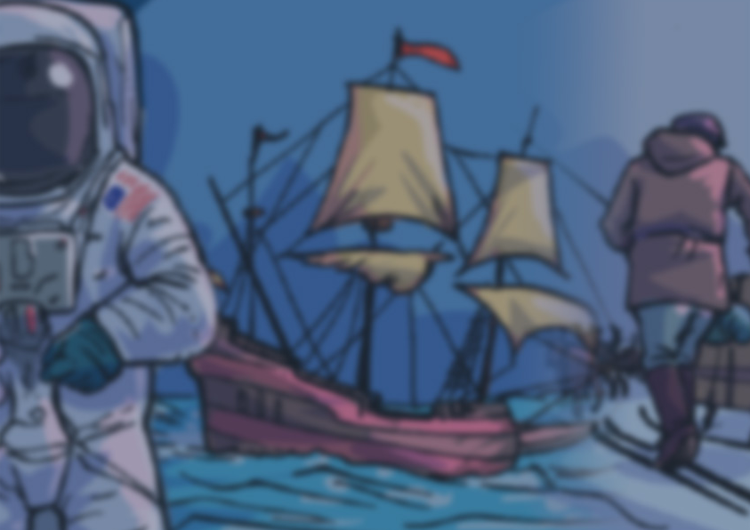
Year 2

Knowledge Organiser

Into the Unknown
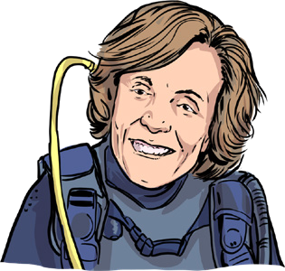
A timeline to help us

Key history vocabulary to help us

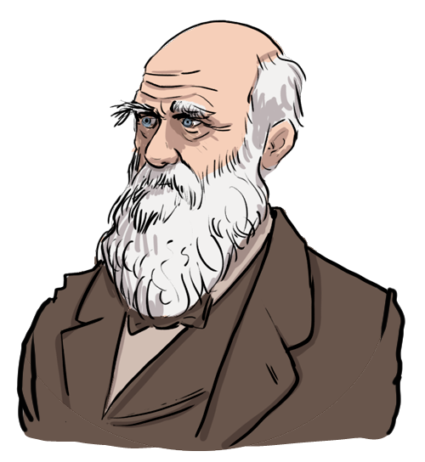
explore | explorer | exploration
astronaut | oceanographer | mountaineer
monument | significant | before
after | past | present
same | different | change
continuity | then | now

1953
Edmund Hillary

2023
now, present


1325
1970s
Sylvia Earle
1831
Charles Darwin
Ibn Battuta

1911
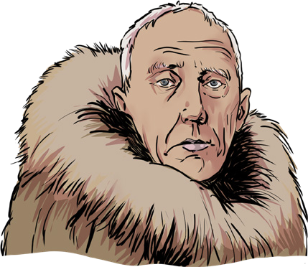
Roald Amundsen

1969
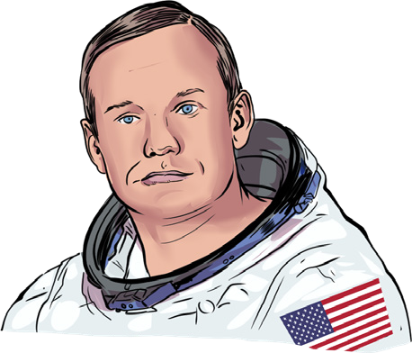
Neil Armstrong

Who are some of the explorers from the past?

Where do humans explore?
Why do humans explore?

How do we find out about the past?
Many people from the past have explored new places, but these explorers are the ones we will focus on in our lessons:
Ibn Battuta – A Moroccan explorer who travelled

Over the years, humans have explored many places on Earth and beyond, including:
- rainforests
- the North and South Poles
- the world’s continents
- deserts
- the world’s oceans
- the Moon
- the world’s highest mountains

Where is left for humans to explore and discover in the future?
The main reasons why humans explore are:
- we want to learn new things
- we are naturally curious about other places
- we want to be the first to discover a new place
- we want to make a difference in our world, to make it a better place
- we want to make amazing

discoveries

www.grammarsaurus.co.uk
We can find out about the past by:
- looking at and reading non-fiction books
- searching the internet
- talking to people who were around at the time that we want to find out about
- watching video clips or TV shows about the time in history we want to find out about
- visiting museums
- looking at photographs
- looking at objects from the past
across many continents.
Charles Darwin – A nature explorer who made important scientific discoveries.
Roald Amundsen- A Polar explorer who was the first to the South Pole.
Edmund Hillary – A mountaineer who climbed to the summit of Mount Everest.
Neil Armstrong – An astronaut who was the first man on the Moon.
Sylvia Earle – An oceanographer who has dedicated her life to exploring and saving the world’s oceans.

