Year 5 – Saxon Settlers and Viking Raiders

Pre-History | Iron Age | Romans  Anglo-Saxons | Medieval |  |  |  |  | Georgians  Stuarts  Tudors | Victorians | Modern
Pre-History | Iron Age | Romans  Anglo-Saxons |  | Vikings  Normans | late Medieval
1603 CE 1714 CE 1837 CE 1901 CE
700 BCE
43 CE
450 CE
790 CE 1066 CE 1300 CE 1485 CE

The Anglo-Saxon Heptarchy
What do we know about the Anglo-Saxons?

The fall of the Roman Empire in 410 CE left England in an unprotected state which led to the Angles, Saxons and Jutes invading from Germany, Denmark and the Netherlands. These invaders settled in England and we know them as the Anglo-Saxons.

Not much is known about the fall of the Roman Empire leading into the early Anglo-Saxon period, as not many people wrote about it. However, most of the written information from this period comes from two monks, Gildas who wrote in the 6th century and Bede, who wrote in the 8th century.

The Anglo-Saxons were mostly farmers who lived in wooden huts. Children here would generally not go to school. Girls would help around the home and boys learned the skills of their fathers.

From the 5th century up until 927 CE, England was not a united country like today and instead it was separated into many kingdoms. Historians refer to the seven largest kingdoms as the 'heptarchy'.

Each kingdom had its own king and they would often fight between each other. Sometimes the people
who lived in the kingdom would rebel against the king’s power.
So, being in complete control of an Anglo-Saxon kingdom required power, influence, and lots of money!

Anglo-Saxon kings had so much power and control over their people that they even worked to change their religion to their own beliefs!

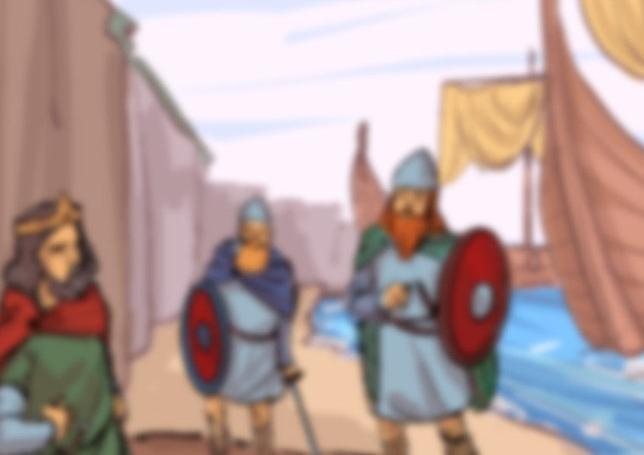

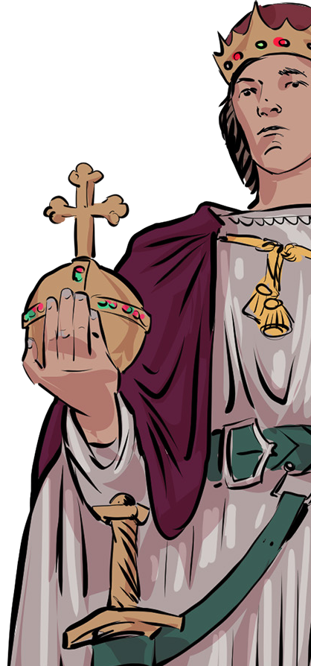
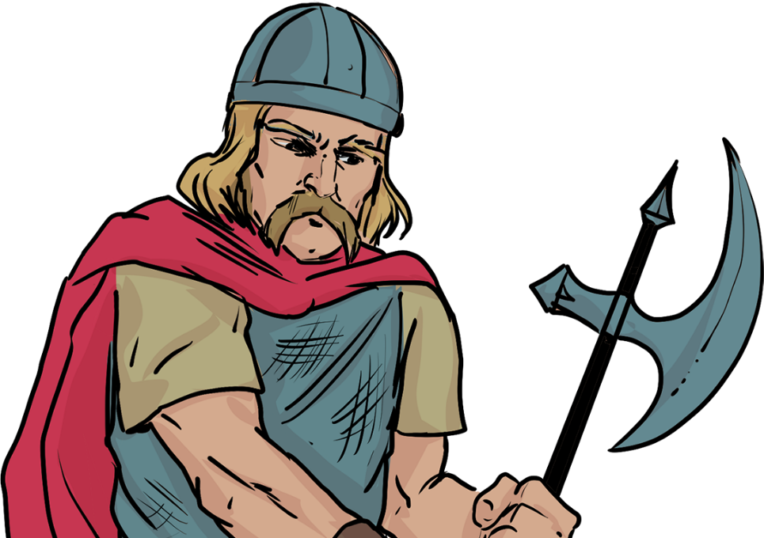
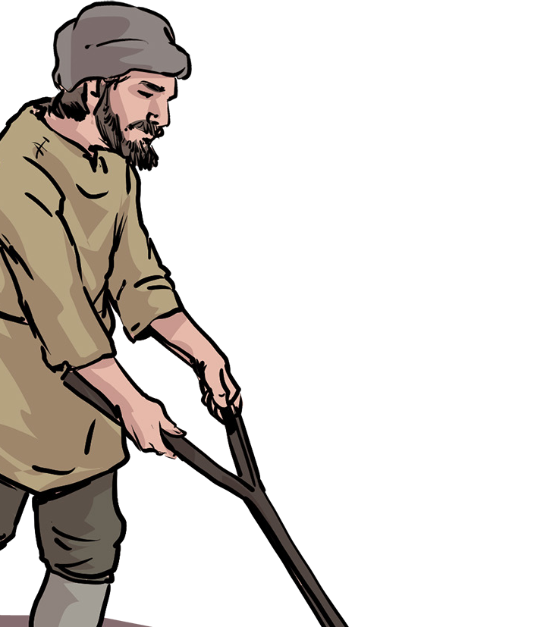
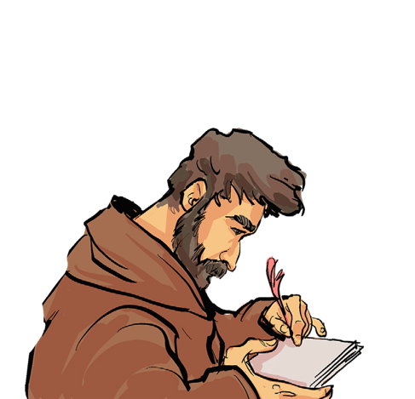
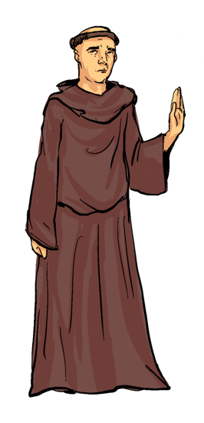
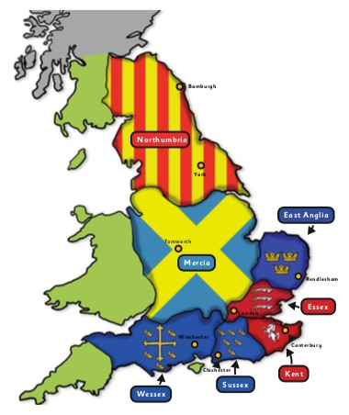

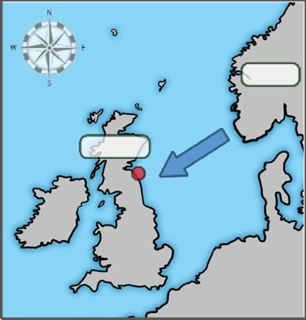
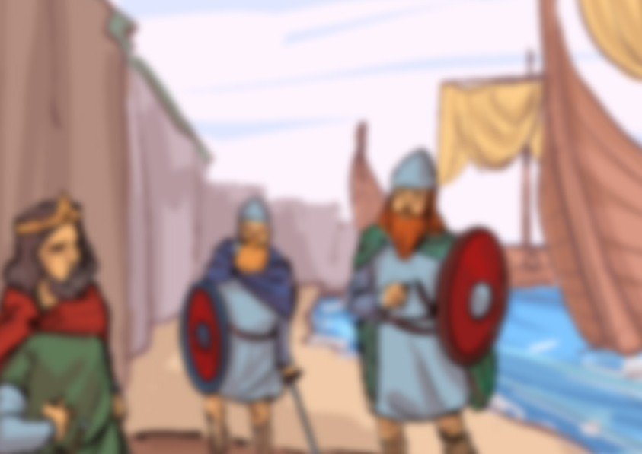
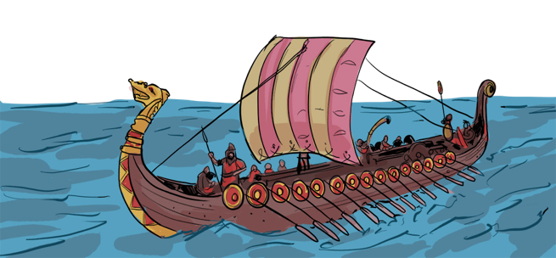
Lindisfarne Priory
In 793 CE, a small island (known as Holy Island) off the coast of Northumbria was home to Lindisfarne priory – a Christian settlement of monks. The priory held many great treasures like gold goblets, silver crosses and jewel-encrusted bibles.
It became the target of a Viking raid (possibly originating from Norway) because it was protected by solders as only monks and villagers lived there.
Even if the monks had been able
to defend themselves, they were
no match for the strength of the
Viking invaders – the Vikings
were skilled in battle – using
shields, swords, spears,
battle axes and arrows.
Anglo-Saxons
Norway
Lindisfarne
The Vikings were famous for being ruthless warriors and astute traders. They set sail in longboats from their homes in Norway, Sweden and Denmark, and raided and traded across Europe. Their raids were sudden and daring, often using surprise to overcome their victims. For Viking warriors, honour and glory in battle lasted forever. Warriors who died bravely were believed to go to Valhalla, the Viking heaven. This belief made them extremely tough, fearless opponents.
Viking raids on the coastline of Britain were very common in the 700s and it would have been common for the people who lived near the coast to be worried about impending attacks from Vikings from Scandinavia.
There were many theories (ideas) as to why these men left Scandinavia to raid and eventually settle in England.

What do we know about the Vikings?
In 793 CE, a small island (known as Holy Island) off the coast of Northumbria was home to Lindisfarne priory – a Christian settlement of monks. The priory held many great treasures like gold goblets, silver crosses and jewel- encrusted bibles.
It became the target of a Viking raid (possibly originating from Norway) because it was not protected by soldiers,
as only monks and villagers lived
there. Even if the monks had
been able to defend themselves,
they were no match for the
strength of the Viking invaders –
the Vikings were skilled in battle –
using shields, swords, spears,
battle axes and arrows.

Lindisfarne Priory

Did the Anglo-Saxons and Vikings live peacefully together?

Georgians
Victorians

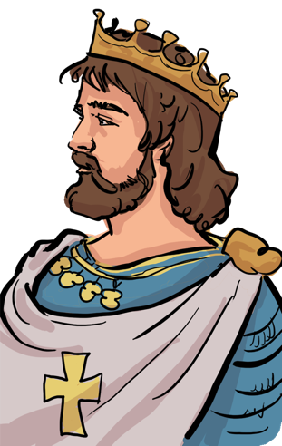
The Vikings’ overwhelming strength and power controlled most of Britain by the end of the 9th century, even though kings like Alfred the Great tried to defeat them.
The land they controlled was named the Danelaw because the rules of these lands came from the Danish (Danes) and Norse overlords who had settled from Scandinavia. Living as an Anglo-Saxon under the Danelaw was very di cult because the lives of Anglo-Saxons were considered less than that of the Dane/Norse people. This all changed after King Alfred the Great made a treaty with invaders saying that the lives of both the Anglo-Saxon and Scandinavians would be treated as equal. It also clearly marked out the territories of Wessex and the Danelaw.
The first king of England
Over the next hundred years, the Anglo-Saxons in Wessex and Mercia fought together to drive back the Danelaw regions and by 927 CE, King Aethelstan had conquered the city of York and all of Northumbria, finally uniting all of England. This makes Aethelstan the first king of England.

