

St John’s C.E. Primary School
Wellbeing for children and adults

We would like to start by saying a HUGE thank you for all of the hard work you are doing during these difficult times. You may have children in school or children at home, you may be a key worker, you may be a stay at home parent. You are like the rest of us trying to find the best way of supporting your children whilst also trying to keep on going. This balancing act is not easy and we appreciate all that you are doing.
It is really important to ensure we are addressing the emotional needs of our pupils alongside education and physical needs so in this letter we are providing you with some ideas, links and activities to help support the wellbeing of your children (and yourselves) as we continue through lockdown.
Routine
Try to keep to a sensible routine:
- Go to bed and get up at a reasonable time.
- Have a timetable for the day and tick off subjects as they have been completed.
- Get the harder subjects completed first.
- Make sure you schedule in breaks between lessons – get up out of your seat and move around.
- Keep hydrated.
- Try to have a quiet and relaxing space for working.
- Do what you can to keep calm and positive, praise goes along way.
- If it’s getting too much to cope with, step away and do some relaxation activities before going back to it.

Mindfulness Activities
Cosmic Zen Den Colouring

Twinkl is a really good site for activities.
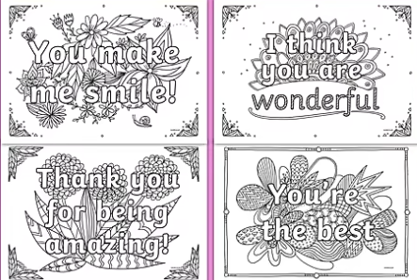
https://www.youtube.com/watch?app=desktop&v=8rp5bpFIUpg

Other activities to try:
Home learning can take many forms (it’s not just about completing school work). As most of the learning is online try to take a break from screens during the day.
Get out if you can do so safely – walking, making dens, collecting leaves to create nature pictures, bird watching are all fun activities that are good for the body and mind.
Indoor activities to try:
- Cooking
- Reading for pleasure
- Painting
- Making
- Playing board games

Talking
We need to make sure we are communicating with our children, asking them certain questions will make them feel at ease and open to express their feelings.
Questions to ask your child:
What things are you looking forward to?
What things would you like to do in the future?
Is there anything you want to talk about?
What can I do to help?
What makes you feel calm?
Where is a place you feel safe?
Do you have any worries about the coronavirus?
How do you feel about things changing?
How do you feel about staying at home?
Can you think of anything fun we can do at home?

Support
Remember we are here for you too.
Please email your class teacher, the school or phone us if you need any help.

office@stjohns.worcs.sch.uk Telephone: 01562 745558
class teachers name@stjohns.worcs.sch.uk

February 2021
R. Taylor

